

**Risk Assessment Form for:**

**Taught Post and Undergraduate Student Dissertations and Projects. Stirling Management School Complete sections A & B (and C1/C2 and D only if required) (Version December 2017)**

To ensure researcher and participant safety in fieldwork and project and dissertation work, this form should be completed by the due date of the ethics application for your Module and prior to the commencement of fieldwork, or other practical work. You and your supervisor should participate in the risk assessment and sign to indicate their agreement with it. Completed and signed forms and copies of all relevant supporting risk assessment forms should be submitted to the Faculty ethics email address for your module with your Ethics Proposal, after signing by your supervisor.

Further information is given in the Appendix. While Safety, Environment and Continuity Department staff will not prepare or approve these risk assessments they will give advice on them where required.

**SECTION A: Safety contacts (complete section A for all activities)**

|  |
| --- |
| **Dean of Faculty: Dean of Stirling Management School** |
| **Faculty support team member:** |
| **University Safety Adviser:** Head of Safety, Environment and Continuity |
| **A1. Emergency contact:** *Please identify primary contacts in the event of an emergency*  **Next of Kin Name:** Click here to enter name **Telephone number(s):** Click here to enter number(s)  **University Contact Name:** Click here to enter name **Telephone number(s):** Click here to enter number(s) |

|  |  |
| --- | --- |
| **A2. Name of student:**  **Matriculation No.:**  **Module Number:**  **Title of dissertation or project to which this form refers, (taught student project or dissertation research and/or fieldwork):** |  |
| **A3. Where is the activity located (country and town or region, e.g. Central Scotland)?**  ***If UK only then go to Section B.***  ***If foreign travel then you must also complete Section D.*** | **General Location:**  **Is travel only in the UK? Yes/No** |

**SECTION B: Post and Undergraduate Taught Student Dissertations and Projects**

|  |  |  |  |  |  |
| --- | --- | --- | --- | --- | --- |
| **B1 Give a brief description of the Taught Postgraduate or Undergraduate Dissertation or Project** | | | | | |
| **B2 Location** | **Is the project based on desktop research, such as accessing literature and safe internet sources? E.g. where all work will be carried out in a library setting or in your home, etc.,**  **OR,**  **Is the project based on questionnaires/surveys/computer programmes completed in a safe environment? E.g. In the University or with the student’s family and friends or work colleagues/classmates.** | | **Yes** | **No** | **If all of the answers to the questions in SECTION B are “Yes” or “Agree” then the form should be signed at B7 by the student and their supervisor.**  **If you answer “NO” or “Disagree” to any of these questions then also complete SECTIONS C1 and C2.** |
| **B3 Equipment** | **Is the equipment to be used free of moving parts or the risk of contact with electricity? (Desktop and laptop computers PDAs, etc. are not regarded as posing a risk.)** | | **Yes** | **No** |
| **B4 Substances** | **Are all substances that are to be used of a type available to the general public, of low toxicity and being used in the manner and amount for which they are sold? (Examples of these are marker pens, lens wipes and non-aggressive cleaning materials.)** | | **Yes** | **No** |
| **B5 Research Subject** | **Does the research avoid sensitive subject matter that could give rise to offence or emotional stress? E.g. there are no questions regarding personal details or family history.** | | **Yes** | **No** |
| **Does the research avoid operations that could cause fatigue or physical stress, or operations that involve lifting, carrying, repetitive movement or exercise?** | | **Yes** | **No** |
| **There are no other significant risks to the researcher or participant that are likely to occur during the research (one example of a significant risk may be interviewing strangers in a potentially unsafe environment)** | | **Agree** | **Disagree** |
| **B6 This project has been assessed as being low risk (taking into account the answers to the above questions and any other relevant matters). If any of the circumstances change then the project will have to be reassessed. Agree/Disagree** | | | | | |
| **B7 Student’s name**  **Signature**  **Date** | | **Supervisor’s name**  **Signature**    **Date** | | | |

**SECTION C: Additional Risk Assessment TO BE COMPLETED *ONLY* IF ANSWERED “No” or “Disagree” IN SECTION B**

**COMPLETE BOTH SECTIONS C1 and C2.**

**SECTION C1**

|  |
| --- |
| **C1. Project title:** Click here to enter project title |
| **C2. Ethics reference number: GUEP/**Select year**/**Click here to enter number |
| **C3. Dates of activity:**  Click here to enter date(s) |
| **C4. Activity:** *Give title and briefly summarise*  Click here to enter text |
| **C5. People involved:** *List individual name(s) or types of people being interviewed*  Click here to enter name(s) |
| **C6. Location(s) of the activity:** *Give specific locations e.g. name of hospital, or town*  Click here to enter location(s)  **Are you intending to undertake research in participants’ homes?   Yes   No** |

**SECTION C2**

|  |  |  |  |  |  |  |  |
| --- | --- | --- | --- | --- | --- | --- | --- |
| **AC1.** **Working in a dangerous area** *e.g. high crime area, area of civil/political unrest, psychiatric unit, prison.*  ***Check with the Foreign and Commonwealth Office Travel Website and with University Insurance Officer prior to any travel overseas.***  *Discuss risk assessment/control measures with the management of any institution involved or with local police/law enforcement.*  *Take into account the possibility of psychological injury (trauma/PTSD and stress) as well as physical injury.*  *Give contact details and measures to be taken in case of emergency.* **Not applicable** | | | | | | | |
| **Hazard(s):**  **Click here to enter text** | **Severity of risk before controls:** | **Likelihood of risk before controls:** | **Overall risk rating before controls (severity x likelihood):** | **Control measure(s):**  Click here to enter text | **Severity of risk after controls:** | **Likelihood of risk after controls:** | **Overall risk rating after controls (severity x likelihood):** |
| **AC2.** **Working or travelling in areas with a high risk of infectious disease.** *Working overseas can expose staff and students to a variety of diseases not normally encountered in the UK. While some of these are relatively trivial, some may result in life changing effects on health, for example, malaria. Other examples are: Malaria, Yellow Fever, Leishmaniasis, Rocky Mountain Spotted Fever (USA), Zika virus (S America) – this is not an exhaustive list.* ***Check with the Foreign and Commonwealth Office Travel Website and with University Insurance Officer prior to any travel overseas.***  ***Staff and students should seek health advice at least 8 weeks prior to travel*** *to allow time for any vaccinations or prophylactic medications to be given, and for these to be effective. Information regarding diseases abroad may be obtained from the Foreign and Commonwealth Office* [*Travel Advice*](https://www.gov.uk/foreign-travel-advice) *website, the NHS “*[*fitfortravel*](http://www.fitfortravel.nhs.uk/destinations.aspx)*” website or the NHS “*[*Choices*](http://www.nhs.uk/NHSEngland/Healthcareabroad/Pages/Healthcareabroad.aspx)*” website; as well as from the University’s Occupational Health Service.*  *Give details potential diseases and measures taken to prevent these or mitigate their potential effects.*  **Not applicable** | | | | | | | |
| **Hazard(s):**  Click here to enter text | **Severity of risk before controls:** | **Likelihood of risk before controls:** | **Overall risk rating before controls (severity x likelihood):** | **Control measure(s):**  Click here to enter text | **Severity of risk after controls:** | **Likelihood of risk after controls:** | **Overall risk rating after controls (severity x likelihood):** |
| **AC3.** **Working in an isolated geographical area.** *An isolated geographical area can include city parks, urban brownfield sites and industrial estates as well as remote hillsides or valleys. Take into account physical isolation through distance, screening effects of shrubbery/woodland or lack of mobile phone signal, etc. rather than just distance from “civilisation”.*  *Give contact details and measures in case of emergency.*  **Not applicable** | | | | | | | |
| **Hazard(s):**  Click here to enter text | **Severity of risk before controls:** | **Likelihood of risk before controls:** | **Overall risk rating before controls (severity x likelihood):** | **Control measure(s):**  Click here to enter text | **Severity of risk after controls:** | **Likelihood of risk after controls:** | **Overall risk rating after controls (severity x likelihood):** |
| **AC4. Lone working:** *Lone working can include unaccompanied visits to research subjects in their own home, etc., as well as working alone in the field. Working alone in an office environment with access to a phone is not usually categorised as “lone working”. Any individual characteristics that could increase the risk must be taken into account, eg., heart condition, diabetes, etc.*  *Give contact details and measures in case of emergency* **Not applicable ☐** | | | | | | | |
| **Hazard(s):**  Click here to enter text | **Severity of risk before controls:** | **Likelihood of risk before controls:** | **Overall risk rating before controls (severity x likelihood):** | **Control measure(s):**  Click here to enter text | **Severity of risk after controls:** | **Likelihood of risk after controls:** | **Overall risk rating after controls (severity x likelihood):** |
| **AC5.** **Working with equipment** *This could include vehicles (competence, licensing, insurance, local regulations), work with analytical or measuring equipment such as lasers, use of drills or other hand or power tools, etc.*  *please detail the risks associated with this* **Not applicable** | | | | | | | |
| **Hazard(s):**  Click here to enter text | **Severity of risk before controls:** | **Likelihood of risk before controls:** | **Overall risk rating before controls (severity x likelihood):** | **Control measure(s):**  Click here to enter text | **Severity of risk after controls:** | **Likelihood of risk after controls:** | **Overall risk rating after controls (severity x likelihood):** |
| **AC6.** **Environmental hazards:** *e.g. extremes of weather (temperature, wind speed, ice, etc.), rough terrain, animals, plants, earthquake, water quality, contaminated land, derelict/unstable buildings are examples of factors to be considered here.*  **Not applicable** | | | | | | | |
| **Hazard(s):**  Click here to enter text | **Severity of risk before controls:** | **Likelihood of risk before controls:** | **Overall risk rating before controls (severity x likelihood):** | **Control measure(s):**  Click here to enter text | **Severity of risk after controls:** | **Likelihood of risk after controls:** | **Overall risk rating after controls (severity x likelihood):** |
| **AC7.** **Chemical & biological hazards** *e.g. laboratory and other chemicals and mixtures (eg, oils, acids, chemical wastes (pre-existing or generated during the project), detergents, crop spraying or fumigation, diseases (of humans, animals or plants), poisonous fauna or flora*.  **If this section is applicable, a full COSHH risk assessment will always be required.**  **Not applicable** | | | | | | | |
| **Hazard(s):**  Click here to enter text | **Severity of risk before controls:** | **Likelihood of risk before controls:** | **Overall risk rating before controls (severity x likelihood):** | **Control measure(s):**  Click here to enter text | **Severity of risk after controls:** | **Likelihood of risk after controls:** | **Overall risk rating after controls (severity x likelihood):** |
| **AC8.** **Manual handling** *e.g. loading and unloading equipment*or samples. In projects involving larger loads, repetitive lifting, or human or animal handling, training additional to the online University handling training will be required.  **Not applicable** | | | | | | | |
| **Hazard(s):**  Click here to enter text | **Severity of risk before controls:** | **Likelihood of risk before controls:** | **Overall risk rating before controls (severity x likelihood):** | **Control measure(s):**  Click here to enter text | **Severity of risk after controls:** | **Likelihood of risk after controls:** | **Overall risk rating after controls (severity x likelihood):** |
| **AC9.** **Emotional risks:** *e.g. sensitive research. This can include many areas that can be emotional triggers – research with or regarding children, animals, conflict (war, terrorism, holocaust studies, etc), and natural disasters. The predisposition of the individuals should always be taken into account as an individual’s emotional triggers depend very much upon that individual’s personal/family history.* **Not applicable** | | | | | | | |
| **Hazard(s):**  Click here to enter text | **Severity of risk before controls:** | **Likelihood of risk before controls:** | **Overall risk rating before controls (severity x likelihood):** | **Control measure(s):**  Click here to enter text | **Severity of risk after controls:** | **Likelihood of risk after controls:** | **Overall risk rating after controls (severity x likelihood):** |

**SECTION D - FOREIGN TRAVEL**

|  |  |  |
| --- | --- | --- |
| **D1. Are there any restrictions on travel to or within the country, city or area you are travelling to.**  **Check the Foreign and Commonwealth Office (FCO) travel website.**  **IF THERE ARE NO RESTRICTIONS AT TIME OF BOOKING THEN CONFIRM THIS IS STILL APPLICABLE IMMEDIATELY PRIOR TO TRAVEL** | **YES**  **Complete ALL sections of this form prior to submission to your supervisor.** | **NO**  **Submit this form to your supervisor with SECTION A completed** |
| **D2. Are any recreational activities included or arranged that could include dangerous activities, e.g., sports such as canoeing, snowboarding, mountain climbing? If so then confirm that you have personal insurance cover that specifically covers these activities, as the University Insurances do not cover recreational activities** | | |
| **D3. Are any trips or excursions arranged that could include travel to near a border with any country that that has had warnings concerning it placed on the FCO travel website – e.g., within China and close to the border with North Korea, or within Russia and close to the border with Ukraine. If this is the case then do not take these trips/excursions or contact SEC prior to travel to discuss them.** | | |
| **D4. Are there any personal health concerns that could affect your ability to travel to your proposed destination? If so please contact Occupational Health prior to arranging travel.** | | |

**The University’s insurers MUST be informed of any work related overseas travel, including for low risk activities, prior to booking travel/flights/ hotels, etc. Failure to do this can result in you not being insured to travel. NB Holiday travel insurance does NOT cover you for working abroad. Insurers may request sight of risk assessments prior to approving cover.**

|  |
| --- |
| **FOR ADMINISTRATIVE USE ONLY:**  **Date received:** Click here to enter a date **Risk assessment completed, signed and dated**  **Comments:**  Click here to enter text |

**Appendix - Completing the Risk Assessment**

A risk assessment must be completed for each project or process. It is a requirement of UK legislation that all work operations be risk assessed.

Completing a risk assessment is not as difficult or complicated as it may first appear. It is a way of recording the simple and logical steps taken to ensure you and others are as safe as reasonably practicable while working. Using a formal structure for this allows the University to ensure that everyone is following the same steps and meeting the same standard.

In the following section there is a Risk Assessment Matrix and an explanation of how to use it. This in turn is followed by a series of sections intended to guide the process. If there is an existing, separate risk assessment for any of these areas (e.g., under COSHH or Manual Handling Operations Regulations) then refer to that assessment and attach it to this document. **If any of the risks are categorised as red in the matrix then Safety, Environment and Continuity must be contacted prior to the work being carried out.** If any of the risks are categorised as orange in the matrix then Safety, Environment and Continuity will provide advice regarding the management of the risks.

Guidance and risk assessment templates are available on the University webpages at: <http://www.stir.ac.uk/safetyandsustainability/safety/a-z/>. Guidance on safety in research “*Responsible Research: Managing health and safety in research: guidance for the not-for-profit secto*r” is available at: <https://www.stir.ac.uk/media/stirling/services/internal/estates-and-campus-services/documents/safety-in-research-2012.pdf>. The Universities and Colleges Employers Association document “*Guidance on Health and Safety in Fieldwork: including offsite visits and travel in the UK and overseas*” is available at: <https://www.stir.ac.uk/media/stirling/services/estates-and-campus-services/documents/Safety-in-Fieldwork-Guide---Current-2018-.pdf>. All of these will assist in carrying out the risk assessment.

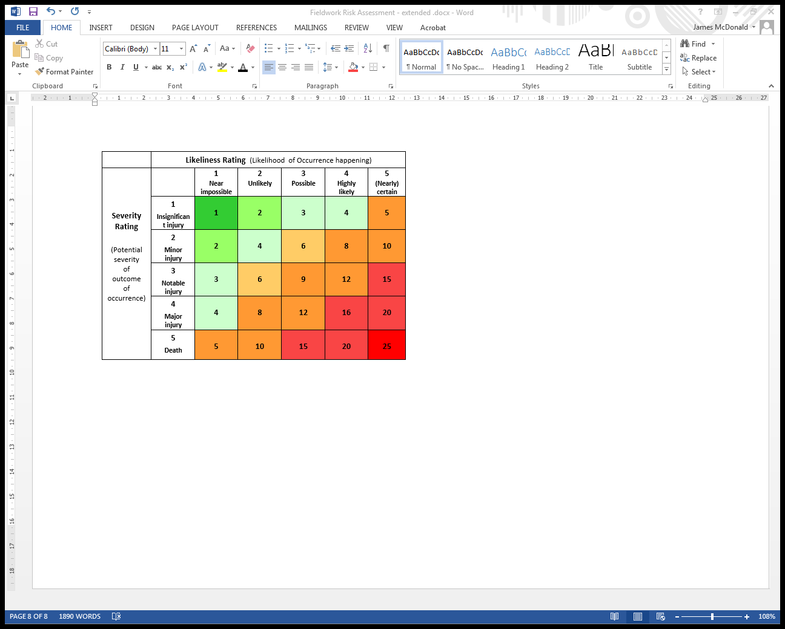To complete a risk assessment in this document follow the simple steps below. Look for the significant hazards. Some examples could include the local political situation/threat of terrorism, slip and trip hazards, persons falling from a height/falling objects (eg rocks), substances in use, use of electrical equipment or working on or above bodies of water.

**Assessment of risk**

1. 1. Think about who might be harmed by these hazards and the potential severity of the effect. Consider all who potentially could be affected (for example: researchers, subjects of the investigation or onlookers/members of the public) and the number of people who could be affected by one incident (one person/few people/many people – the more people likely to be affected then the greater the potential severity).
2. Look at the left hand column of the matrix on the left to see the choice of *Severity Ratings.* Consider the likelihood of the hazard affecting the individual or group using the *Likelihood Ratings* given on the top row of the matrix. Work to the potential worst case scenario.
3. Assign a *Likeliness Rating* and a *Severity Rating* to the hazard and risk. Use a scale of 1 to 5 where 1 equals a near impossible risk of occurrence or insignificant severity of outcome and 5 equals a certain or near certain risk of occurrence or death. Again, work to the worst possible scenario.
4. Calculate a *Risk Factor* (prior to controls or precautions being put in place) by multiplying the *Likeliness Rating* and *Severity Rating*. Look at the matrix on the left for an indication of how this scale works.
5. The risk assessment should be documented using the templates available at <http://www.stir.ac.uk/safetyandsustainability/safety/a-z/>.
6. **Risk factors that are in the green sector (1 – 4) may be further reduced with control measures (but only if this is easily achieved). Risk factors that are orange (5 -12) should be reduced further to “as low as reasonably practicable”. Risk factors that are red (15 – 25) must be reduced by additional controls and precautions, or the work prevented from commencing or stopped/suspended pending discussion with SEC.**
7. Consider the current controls or precautions, and decide on any new ones required. When deciding on new precautions, always refer to the [**Hierarchy**](http://paperclip.rcs.ac.uk/index.php/Risk_Assessments#hierarchy)**of Control** (see below) and use preventative methods (which will reduce the likeliness of an accident), before using protective measures (which will only reduce the severity of the injury). Record what control measures will be used to reduce the risk.
8. Recalculate the Risk Factor taking into account the effect of the new controls and precautions in reducing the risk. Sign off the Risk Assessment and **ensure that the controls and precautions are implemented prior to the commencement of the project or operation**.
9. Review the risk assessment at least every year, or immediately it is found that there are significant reasons to do so – an accident, alterations to protocols/procedures, new staff/students working on the project, recommencement of work following a significant break. For field trips it is worth reviewing the risk assessment immediately following the trip taking into account the input from all involved. In this way the risk assessment can be continually improved.

**Hierarchy of Control**

The following methods of risk control should be examined in the order given as they decrease in effectiveness from elimination downwards. In practice, risk reduction usually includes more than one of these control methods. Personal protective Equipment (PPE) should always be the last option considered and should be used only to remove the residual risk left after all others have been considered. **However, PPE should always be used during wet work (using chemicals, drug solutions, biologicals, etc.), whether in the laboratory or the field – as a minimum, eye protection or face protection, gloves and lab coat or overall must be worn.**

**Elimination**

Eliminating the hazard – actually removing it – is the most effective hazard control. For example, if researchers must interview subjects in an area where violent crime is an issue, conducting interviews via skype will eliminate the threat of violence.

**Substitution**

Substitution, the second most effective hazard control and is similar to elimination, involves replacing something that produces a hazard with something that does not produce a hazard – for example, using water based paints instead of organic solvent based ones. To be an effective control, the new product must not produce [an additional or equivalent hazard](https://en.wikipedia.org/wiki/Unintended_consequences).

**Engineering controls**

The third most effective means of controlling hazards is engineered controls. These do not eliminate hazards, but rather separate people at risk from the hazards.  Examples could include fencing/barriers to enclose hazardous processes or properly designed interview rooms when interviewing prisoners in jails. Local exhaust ventilation such as fume cupboards is also an engineering control.

**Administrative controls**

Administrative controls are changes to the way people work. Examples of administrative controls include systems such as training to ensure health and safety competence, team working and check-in procedures when conducting home visits, interviewing children in the presence of adults and ensuring that the researchers are PVG checked, installation of signs and warning labels, restriction of access to reduce numbers potentially exposed, safe systems of work and operating procedures.   Administrative controls do not remove hazards, but limit or prevent people's exposure to the hazards.

**Personal protective equipment**

[Personal protective equipment](https://en.wikipedia.org/wiki/Personal_Protective_Equipment) (PPE) includes gloves, weatherproof clothing, [respirators](https://en.wikipedia.org/wiki/Respirator), [hard hats](https://en.wikipedia.org/wiki/Hard_hat), [safety glasses](https://en.wikipedia.org/wiki/Safety_glasses), [high-visibility clothing](https://en.wikipedia.org/wiki/High-visibility_clothing), and safety footwear. PPE is the least effective means of controlling hazards because of the high potential for damage to render PPE ineffective.  Additionally, some PPE, such as respirators, increase physiological effort to complete a task and, therefore, may require medical examinations to ensure workers can use the PPE without risking their health.