Health Concerns and Service Engagement in Older Adults in Scotland

Informing recovery from the COVID-19 pandemic

­­

­

Logo of The University of Stirling

On 28 June 2022, the Scottish Parliament passed [the Coronavirus (Recovery and Reform) (Scotland) Act 2022](https://www.legislation.gov.uk/asp/2022/8/contents/enacted) to help Scotland recover from the pandemic and ensure greater resilience against future public health threats. The Act supports the Scottish Government’s [Covid Recovery Strategy](https://www.gov.scot/publications/covid-recovery-strategy-fairer-future/) andthe updated [Covid Strategic Framework](https://www.gov.scot/publications/coronavirus-covid-19-scotlands-strategic-framework-update-february-2022/),which reflect a shift in emphasis away from legislation and towards people and organisations, as Scotland looks towards broader aspects of recovery.

By informing policymakers and practitioners of our findings from the Healthy Ageing in Scotland (HAGIS) study, we can support Scotland in its recovery from the pandemic. Our research contrasts older people’s concerns relating to access to health services and a range of other public settings.

As the National Health Service and other public services work to address a backlog caused by the impacts of pandemic, our findings have implications for health service confidence that older people will attend appointments when invited and are not put off by fears of contracting COVID-19.

Key findings

* Older people still worry most about dementia (29%) and cancer (30%) above other health conditions, including COVID-19 (5%).
* How often people worry about cancer may have increased from pre- to post-COVID-19 (based on English pre-Covid data): in 2016, 5% of survey respondents worried often or very often about getting cancer compared to our finding of 13%.
* Older people living in Scotland are concerned about being able to access GP and NHS services: 33% reflected they were very/extremely worried about access during the pandemic and 23% remain so when considering the year ahead.
* Worry about catching COVID-19 did not prevent older adults from attempting to engage with health services during the pandemic. Access to health services was largely considered to be due to service provider issues, such as cancelled or rescheduled appointments, or no availability of appointments.
* Individual level concerns over COVID-19 were not indicated as a common reason for cancelled appointments:
  + Only 4% of those who experienced cancellations and delays from health services indicated this was a result of their own fear of getting COVID-19.
  + 55% were ‘not worried at all’ about physically going into a GP or hospital setting.
* Older people living in Scotland are confident that they will be safer from contracting COVID-19 while attending their GP or another healthcare setting such as their local pharmacy than in other settings (see Figure A).
  + 63-78% are ‘completely’ or ‘fairly’ confident of being safe from catching COVID-19 in a pharmacy or GP surgery with only 2-6% ‘not confident at all’.
  + However, 23-28% are ‘not confident at all’ attending a crowded shopping centre, bar, or cinema.

Study

The Healthy Ageing in Scotland (HAGIS) COVID-19 Impact and Recovery Study is a multidisciplinary, large-scale study of older adults (aged 50) living in Scotland. The study explored COVID-19 concerns in older adults and its impact on their willingness to (re)engage across health, social, and economic domains as Scotland’s economy and society emerged from the pandemic.

The survey was made of up eight modules covering these topics. Data were collected between October 2021 and January 2022 via multiple remote modes of survey delivery and completion (i.e. electronic, telephone or postal). 3,373 people completed the survey overall, with 2,687(79.7%) randomised to complete the module relating to health engagement.

The sample comprised 59% men and 41% women, 61% retired, 33% employed (incl. self-employed), and 6% other (homemaker, unemployed, sick, disabled, in education). Further details on the methodology applied and sample composition is available in our protocol (under review with BMJ Open) and on our website: <https://www.hagis.scot>.

***Figure A***

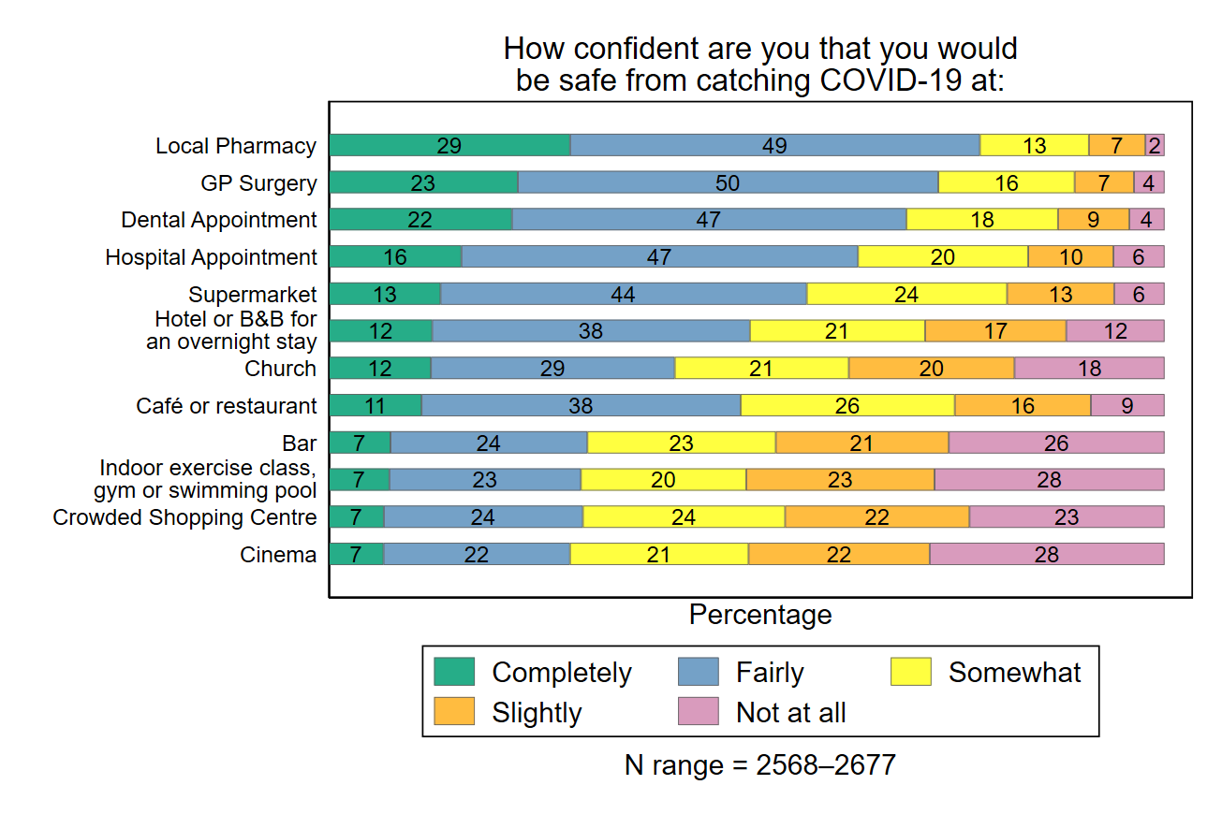

Implications for policy and practice

* Older adults living in Scotland continue to focus their health concerns mainly on cancer and dementia. Reassurance that these remain important public health priorities, supported with easy access to healthcare when needed, is an important public health message.
* Older adults in Scotland are confident they would be safe from COVID-19 in healthcare settings and are not therefore worried about physically attending an appointment. Getting access to the care they need is the main concern.
* Our data indicates respondents were most confident about being safe from COVID-19 in healthcare settings. Reasons for this are not clear within this dataset, but may relate to trusting that healthcare settings will be managed in a way to keep risk of transmission low.
* This level of confidence contrasted sharply with larger, indoor public events and activities where the support of people to abide by risk reducing measures was perhaps less guaranteed. This is important to note as, if there was another wave of COVID-19 or another pandemic, it is unlikely that people would be put off contacting health services, and that the availability of services is key to minimising health related worries.
* Policymakers and practitioners should focus on health service provider issues rather than individual level barriers to access and engagement with health and care services.

About this research

This briefing is based on research undertaken by:

* Dr Elaine Douglas, Associate Professor/Principal Investigator, Faculty of Social Sciences, University of Stirling
* Dr Lesley McGregor, Senior Lecturer in Psychology, Faculty of Natural Sciences, University of Stirling
* Dr Tamara Brown, Research Fellow, Faculty of Social Sciences, University of Stirling
* Dr Alan Duggan, Research Fellow, Faculty of Social Sciences, University of Stirling
* HAGIS Covid Recovery study team [TEAM | Healthy Ageing in Scotland (HAGIS)](https://www.hagis.scot/hagis-team) and co-researchers [CO-RESEARCHERS | Healthy Ageing in Scotland (HAGIS)](https://www.hagis.scot/hagis-co-researchers)

 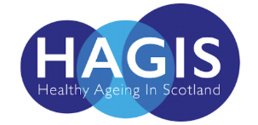

This study is funded by the Economic and Social Research Council (ESRC), as part of UK Research and Innovation’s (UKRI) rapid response to COVID-19. UKRI ESRC supports this study as part of their aim to further understand the impact of COVID-19 on the UK population.More information can be found on <https://www.hagis.scot/>

If citing this research, please refer to **McGregor L, Brown TJ, Douglas E. COVID-19 and You: *Impact and Recovery Study. Engagement with health services in Scotland during the Pandemic.* Rapid Report. Stirling University: Scotland, UK; 2022 McGregor L, Brown TJ, Douglas E. COVID-19 and You: *Impact and Recovery Study. Has the pandemic changed older people’s worries about health?* Rapid Report. Stirling University: Scotland, UK; 2022.**

­­­

**Contact**

**Dr Elaine Douglas**

**Faculty of Social Sciences** **November 2022**