
THE TRUMPET
Stirling Law School’s Bulletin 2/2024
This bulletin is for sharing Stirling Law School’s achievements in research, teaching, and citizenship. This recognises the importance of celebrating successes, strengthening our sense of community, and creating opportunities for cross-Faculty and cross-University collaborations. We hope you’ll enjoy these snippets of Stirling Law School’s recent successes.
Table of Contents

Impact and engagement 1
Publications 2
Journal articles 2
Chapters 4
Esteem, network, and citizenship 4
Dissemination and media presence 6
Internationalisation 7
Events 7
Staff announcement 7
Get in touch 8

Impact and engagement

Dr Domenico Carolei has been awarded the Society of Legal Scholars (SLS) Small Projects and Events Fund. This project aims to enhance accountability within international non-governmental organisations (NGOs) through a one-day workshop at the University of Stirling in March 2025. It brings together researchers, NGO representatives, and policymakers to explore normative proposals and frameworks. The project’s core objectives are to foster dialogue on NGO law and accountability, create a collaborative network, and promote legal research on NGO accountability and charity law. A call for papers will be released in early autumn.

Dr Domenico Carolei and Dr Nadia Bernaz’s research article, published for the Journal of Human Rights Practice (2021), has been cited by Amnesty International in their report, China’s Targeting of Overseas Students Stifles Rights (May 2024).

On page 54, Amnesty cite Dr Carolei’s work emphasising that the UNGPs should also guide universities, not just businesses, in respecting the rights of overseas students:

“There is a growing understanding that the UN Guiding Principles are an appropriate standard for assessing the human rights responsibilities of organizations that are not ‘businesses’”.

The full report is available for download here.

Dr Tracy Kirk, in her advisory role with Scottish Government advisory groups on children’s rights implementation, is working with organisations across Scotland to support their understanding of interpreting the UNCRC.

Dr Tracy Kirk has been invited to support the Scottish Youth Parliament in the Scottish Parliament during Autumn 2024.

Dr Edit Frenyo (Co-I; Stirling) and Professor Renee Luthra (PI; University of Essex) have recently secured a successful funding bid (£171,899) from the Nuffield Foundations Research, Development and Analysis Fund, for their project on “Immigrants in the family justice system”. This is a two-year, interdisciplinary research project with significant impact potential and will start in January 2025.

The project will entail a combination of desk research and interviews with parents, mediators, family and immigration lawyers, judges, and third sector organisations. The aims include improved information for immigrant families, better cross-jurisdictional competence for practitioners, and providing a significant push to existing advocacy for the expansion of legal aid eligibility, accessible family and visitor visas to enable post-separation family life, and arguments for a specialised immigration family court.

Professor Annalisa Savaresi led a session on "Developments before the European Court of Human Rights" at the Summer School on "Climate Change Liability and the Rights of Future Generations," which took place at the University of Insubria, Como, Italy, from 15-19th July.

Publications

Journal articles

Dr Tracy Kirk is co-editing a special edition of the Child and Family Law Quarterly on Children’s Rights and Temporality to be published in 2025. The title of the special edition is: Temporal Fluidity of Childhood and Children’s Rights. This special edition brings together global scholarship that addresses the temporality of childhood and children’s rights in specific contexts. As part of the special edition Dr Kirk will be publishing a peer reviewed article on the Minimum Age of Criminal Responsibility and Covid 19. She will also be publishing a peer reviewed editorial.

Dr David McArdle’s latest paper, “Litigation and Liability in Concussion research and Collaboration”, appeared online in Sport, Ethics and Philosophy prior to being part of an edited volume to be published in the autumn. Written with Anne DeMartini of Troutman Pepper LLP in Atlanta GA, the paper engages US, English and Scots law to explore the difficulties of establishing liability for injuries arising from sports-related concussion (SRC). It explains why the current class actions over historically-acquired injuries in various football codes are not entirely without merit, but notes that the inherent difficulties in establishing liability for personal injury will always be exacerbated by the specific characteristics of SRC and the legal, factual and evidential issues that arise in those situations. For those reasons, the paper considers the potential benefits of other means of concussion prevention and mitigation, including no-fault compensation and mandatory insurance, and the more widespread use of effective, nuanced concussion protocols.

The paper had over 300 views in the first six weeks since publication and is available to view here.

Professor Francis McManus published the following case analysis in the Northern Ireland Law Quarterly: “A continuing nuisance: Jalla v Shell International Trading and Shipping Co Ltd [2023] UKSC 16” (2024) 75 NILQ 397. This is available to view here.

Abstract: In Jalla the Supreme Court was required to decide whether the damage, which had been caused to the claimants’ land by the continued presence of oil on the land, which in turn had been caused by a spill from the defendants’ oil pipeline, constituted a continuing nuisance, the upshot of which was that a continuing cause of action accrued afresh from day to day. The court held that a continuing nuisance was a nuisance which continued day after day, or on another regular basis. In such cases, the cause of action continued afresh on a continuing basis. However, in Jalla the court held that there was no continuing nuisance, on the grounds that there was no repeated activity, or continuing state of affairs, which had been caused by the defendants. Rather, the leak was a one-off event, or isolated escape, which had been caused by the defendants. The cause of action was complete once the claimants’ land was affected by the oil spill. In short, there was no continuing cause of action for as long as the oil remained on the claimants’ land. Whereas the presence of the oil on the claimants’ land may have ranked as a ‘nuisance’ in common parlance, the continuing presence of the oil on the land did not rank as a nuisance in law. The author concludes that Jalla illustrates the confusion which stems from the fact that the concept of nuisance is not clearly defined.

Dr Pontian Okoli (and Dr Etisang Abraham) authored “In search of a sustainable future: a comparative assessment of climate change regimes in Nigeria and Kenya” (2024) 33(2) Review of European, Comparative and International Environmental Law 276-290. This is available to view here.

Abstract: Climate change has caused significant hardship in sub-Saharan Africa. As a result, Kenya and Nigeria now have statutes that focus on climate change mitigation and adaptation. Both countries are also parties to the Paris Agreement. The Kenyan Climate Change Act (2016) and the Nigerian Climate Change Act (2021) are similar in terms of their design and overarching aims. Meanwhile, certain pivotal statutory provisions in both statutes are inconsistent with their overarching aims of enhancing appropriate responses to climate change. Further, despite their similarities, the divergent approaches of the statutes undermine regional coherence. Such coherence is critical to effectively addressing climate change because both regional powers face similar vulnerabilities with respect to climate change and socio-economic challenges. This article, therefore, undertakes a comparative analysis of the Kenyan and Nigerian legal regimes in two key respects, namely, (1) institutional structures and how they impact corruption and (2) accessing justice in the context of climate litigation. The article concludes by examining how the Aarhus Convention and the International Access to Justice Convention can help to fill any statutory gaps concerning access to justice.

Chapters

Dr Pontian Okoli authored Chapter 25 (“South Africa”) of Private International Law in BRICS: Convergence, Divergence and Reciprocal Lessons (pages 509-539); edited by Stellina Jolly and Saloni Khanderia.

Abstract: The chapter examines the relevant regimes that govern the recognition and enforcement of foreign judgments and arbitral awards in BRICS countries: Brazil, Russia, India, China and South Africa. There is an argument for ‘purposive flexibility’ in exploring the extent to which benefits of the 2019 Judgments Convention, the 2005 Hague Convention on Choice of Court Agreements, and the 1958 New York Convention on arbitral awards may be maximised. The chapter provides an analytical mechanism to promote the enforcement of obligations through a constructive approach to dispute resolution Conventions, including Hague Conference Conventions (where they have been ratified) and national or domestic laws. Courts of other countries can also use ‘purposive flexibility’ in navigating common spaces between litigation and arbitration to ensure a cohesive approach concerning the enforcement of obligations in international commercial disputes. Combined BRICS members’ economies are now worth more than $28.5tr (which is about 28% of the global economy).

Esteem, network, and citizenship

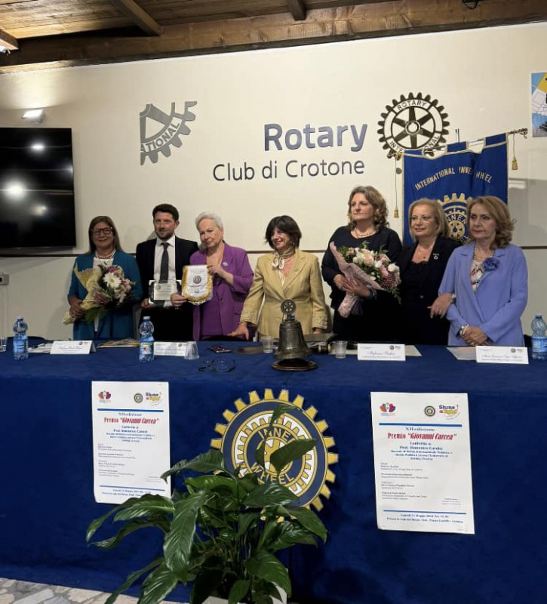
Dr Domenico Carolei was honoured with the "Giovanni Carcea" prize by Inner Wheel Italy in recognition of his dedication and contributions to the field of human rights. This prestigious award is awarded annually to young talents from Crotone, Calabria (Italy).

Dr Carolei's work was discussed by Professor Paola Barbara Helzel, Professor in Philosophy of Law, from the University of Calabria, who also supervised his LLB dissertation in the academic year 2012/13. A report in Italian, along with pictures from the ceremony, is available here.

Figure 1: Dr Domenico Carolei accepting his award.

Professor Annalisa Savaresi participated in the UK Environmental Law Agencies meeting held in Cardiff, Wales on 14-15th August.

Professor Annalisa Savaresi served as the examiner for Justine Muller's PhD thesis at the European University Institute in Florence, Italy on 26th June.

Dr Tracy Kirk was invited to present at the annual Children’s Youth Justice Conference held at Stirling Court Hotel in June 2024.

Dr Tracy Kirk is on the editorial board for a special edition of an interdisciplinary journal examining Marginalised Populations in Youth Justice Systems. The call for papers is open until 15th October here and is included below for any colleagues who may wish to make a submission:

“It is perhaps timely, especially post-pandemic and during a time of significant political, economic and social change, that an opportunity is afforded for the bringing together of research which explores the ways in which youth justice systems treat and/or impact upon children in marginalized populations. The term ‘marginalised populations’ is used broadly in this Special Edition and could embrace those, for instance, from differing ethnic, religious, economic, geographical or ‘settled/non-settled’ populations.

Authors from a range of disciplines are invited to contribute to this Special Edition. Content will include (but is not limited to):

- Research which critically considers the nature of ‘marginalised populations’ and what such a label may mean to a child who is in/or considered to be in a marginalized population

- Enquiry exploring not just prevalent Western constructions of ‘justice’ and ‘marginalisation’, but also global perspectives

- Analyses of the ways in which states, using their authority to regulate youth justice systems, may create social and/or hidden harms for children in marginalised populations

- Critical considerations of legal and social policy frameworks (reflections on child or human rights-related facets of frameworks would be welcomed) which exist in differing jurisdictions and the moral, sociological and criminological implications associated with the ways that these operate in relation to marginalized populations

- What research says concerning gaps in law, policy and service provision for children (including their ability to be heard and influence system change) and the potential for system reform to better support those who are members of/considered to be part of marginalised populations”

Those who wish to be considered for inclusion in this Special Edition should send extended abstracts to the lead Guest Editor, Dr Anthony Charles (a.d.charles@swansea.ac.uk) by 15th October 2024. If accepted, final papers for the Special Edition will be required by 30th April 2025. Further information is available here.

RATE (Recognising and Advancing Teaching Excellence) Awards 2024

Congratulations to Dr Damian Etone and Dr Pontian Okoli who were shortlisted for the Teacher of the Year (Arts and Humanities) award, and to Professor Hong-Lin Yu, who was runner-up for this award.

Congratulations to Dr Damian Etone for additionally being shortlisted for the Outstanding Academic Mentorship award.

Dissemination and media presence

Dr Pontian Okoli was invited to deliver a paper (“The Emergent Role of Party Autonomy in Artificial Intelligence”) at IP and Technology for Development in the Global South: Opportunities and Challenges for Africa (University of Hertfordshire, 13-14th June 2024). The paper assessed complex issues in developing countries and emergent economies vis-à-vis legal implications for cross-border contracts and torts.

Dr Domenico Carolei was invited to present his research on NGO law in the Globalisation & Law Network seminar series which took place on 12th June 2024 at the University of Maastricht (The Netherlands). You can read more about this event here.

Professor Annalisa Savaresi was interviewed by The Wave about her research on just transition litigation. The full interview is available to read here.

Professor Annalisa Savaresi’s entry on the “Environment and Human Rights” in the Max Planck Encyclopedia of Public International Law was selected for showcase and has been made freely available as part of OUP's showcase for the 19th European Society of International Law (ESIL) annual conference in Vilnius, Lithuania. The entry can be viewed here.

Dr Jayne Holliday and Professor Paul Beaumont gave papers at a symposium at the University of Sheffield Law School on 6th September 2024 to honour an outstanding scholar and lawmaker – Professor David McClean FBA – see A Symposium for Professor David McClean CBE KC (Hon) | Law | The University of Sheffield. Jayne spoke on David’s contribution as a scholar and negotiator on the Hague Child Abduction Convention 1980 and the Hague Child Protection Convention 1996. Paul worked together with David on the negotiation of the Hague Maintenance Convention 2007 and enjoyed going over David’s very significant contribution to that Convention, particularly in protecting the Commonwealth scheme for making and enforcing cross-border maintenance orders. David spoke very highly of Jayne and Paul’s contribution to the discipline of private international law through their work in editing A Guide to Global Private International Law (Hart, 2022).

Internationalisation

Dr Tracy Kirk has been invited to work with children’s rights colleagues in Australia to showcase what Scotland have done to incorporate the UNCRC and how Australia may learn from our journey.

Events

The University of Stirling hosted the Scottish International Law Conference 2024, which took place on 10th and 11th of September at the Stirling Court Hotel. The 2024 edition of the Scottish International Law Conference focused on the theme of "Human Rights Incorporation," exploring the integration of international human rights obligations into national law. This event built on previous conferences in the series, hosted by the Universities of Dundee in 2023, Aberdeen in 2022, Edinburgh in 2019, and Glasgow in 2018. Generously sponsored by The Clark Foundation for Legal Education, the conference brought together experts interested in the implementation of international human rights obligations across the UK. Its timing was particularly significant, coinciding with the ongoing debate in the Scottish Parliament regarding a Scottish Human Rights Bill.

More information about the conference can be found on the event page: Scottish International Law Conference 2024 | About | University of Stirling

Professor Hong-Lin Yu has invited the Director of Scottish Mediation, Mr Graham Boyack, to deliver two guest lectures to LAWU9AC (Alternative Commercial Dispute Resolution) students on 19th September and 26th September 2024. The talks address the role played by mediation in the Scottish civil justice system, how it may influence debates on access to civil justice in Scotland, and steps taken in England and Wales.

Graham Boyack has been Director of Scottish Mediation since August 2012. During that period, he has contributed to policy as a member of the Scottish Government Administrative Justice review, the Digital Justice Working Group and, more recently, on a working group on Marches and Parades in Scotland. He is a mediator with the Edinburgh Sheriff Court Mediation Service, has an MBA and is a Fellow of the Chartered Management Institute. Graham has worked extensively in the third and public sectors and brings senior leadership experience, having worked in Student Unions, The Festival City Theatres Trust and the Scottish Ambulance Service. Graham is a graduate of the University of Stirling (with a degree in Political Studies).

Staff announcement

Since the last issue, we are delighted to announce that Mr Alexander Houghton has joined us as a Lecturer in Law. We wish him all the best in his new role!

Get in touch

If you would like to contribute or suggest anything for future bulletins, please get in touch with Robbie here.

