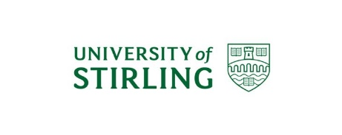
Stirling FAH PG Conference 2024: “Change and Disruption”

Venue: University of Stirling, Pathfoot Building, P.D1 and P.LTA96
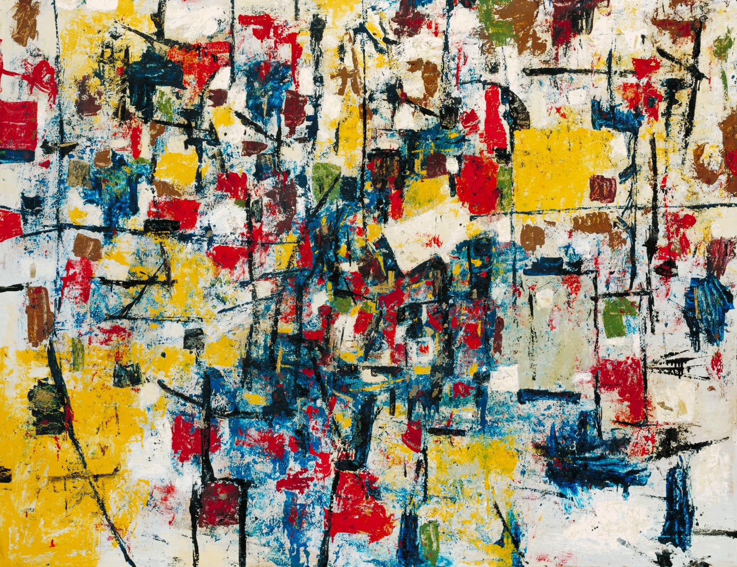
The Change, Ralph Rumney, 1957. Photo: © Tate, London 2024

9:30-10:00: Registration and Welcome [P.D1]

10:00-11:00 Keynote 1 [P.D1]
Anindya Raychaudri (UStA): “‘Really Fantastic Humanising’: Disorienting Technology and Vertigo as Disruption”

11:00-11:15 Coffee Break [P.D1]

11:15-12:45 Panel 1: Literature [P.LTA96] Chair: Eeva Savolainen
- Eeva Savolainen (UoS+UoG): “Stethoscopic Deceit in Round the Red Lamp”
- Maria Gemma Silva Ferrandez (UoS): “The DisruptiveEffects of Identity Branding on Lord Byron’s Reputation”
- Sónia Aires de Lima (University of Lisbon): “Emily Brontë’s Tales of Gondal: Children transforming and recontextualizing Cultural Memory”
- Emma Rose Barrett Ettinger (UoG): “‘In Memory Everything Seems to Happen to Music’: Variations on The Glass Menagerie in Dancing at Lughnasa and Bernie and Mikey’s Trip to the Moon”
- Katherine Heller (UoE): “Fan Audiences and Changing Manga and Anime (Re)translation Strategies: The Case of Sailor Moon”

11:15-12:45 Panel 2: History and Politics [P.D1] Chair: Katie MacLean
- Tadeo J. Vázquez Sánchez (UoS): “The Populist Radical Right and the Discursive Construction of Discrimination and Stigmatisation of Minorities: The Case of VOX and the Spanish Transgender Act (Ley Trans)”
- Martin Odey Wonah (UoS): “Human Rights at Risk: Towards a Safe Use of AI”
- Rebeka Erdelyiova (Newcastle University): “‘The Wickedest Man in the World’?:Popular Culture, Evil Figures, and the Occult Sensationalised”
- Jennifer Robertson (UoS): “Un-Making History: Austen’s Lays Siege to the Certainties of Historical Form”
- Duncan Armstrong (Masters, UoS): “‘The P.O.W. Arms’: Creativity, Emotions and Lived Experiences of Prisoners of War captured during the North Africa Campaigns” [Lightning Talk]

12:45-13:45 Lunch [P.D1]

13:45-15:00 Panel 3: Language [P.LTA96] Chair: Katie MacLean
- Emma Dussouchaud-Esclamadon (UoE): “Current Subtitling Strategies for Films in Sámi Languages”
- Yidan Hu (UoG): “Contesting Chinoiserie Fantasy: Hsiung’s Adaptation of Lady Precious Stream”
- Yiming Liu (UoS): “Changes in the Translation Process of Science Fictions into Chinese since the 1900s”
- Ang Li (UoS): “Men or Women? Gender Transformation in Liaozhai”

13:45-15:00 Panel 4: Identity [P.D1] Chair: Eeva Savolainen
- Irina Nakonechna (UoS): “Unsettled Inheritance: Scottish Identity and Argentinian Literature, 1960-Present"
- Xinyi Gao (UoS): “Questionnaires to Ethnic Minorities in the Post-pandemic Era: The Art of Distribution”
- Minlin Yu (UoG): “Dimming the Grey: The Socio-Cultural Recasting of Aging Women in Chinese Translations of Jane Eyre”
- Joseph Brett-Demetre (UoS): “Coal and Champagne: Sensational Depictions of Coal Miners during the Coal Famine of 1873”

15:00-15:15 Coffee Break [P.D1]

15:15-16:15 Panel 5: Land [P.LTA96] Chair: Gema Silva
- Dinos Pappas (UoS): “Decolonizing Interpretations and Navigating Self-Determination: A Review of the Journal of American Indian Education (1970-79)”
- Carla M. Soares (University of Lisbon): “Cities in Twenty-First Century Science-Fiction Film: Examples of Disruption and Transformation”
- Alina Botezatu (UoS): “Riding the Waves of Change: Trinity House of Leith as Heritage Assemblage”

16:15-17:15 Keynote 2 [P.LTA96]
Tom Mole (DU): “Print Hypertrophy and Media Change”

17:15 Closing Remarks [P.LTA96]

