**Chapter 1: Canterbury**

*Of oystercatchers and Foxes*

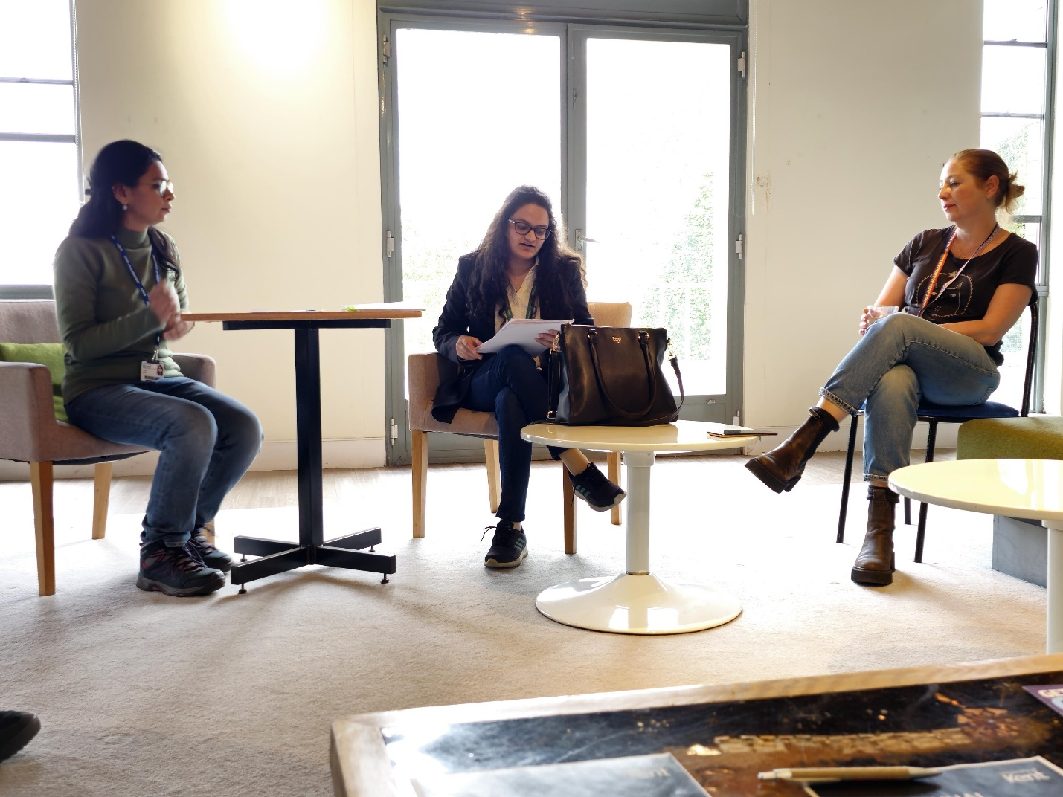

*A Special Collaborative reading at University of Kent*

Oystercatchers crowded my subconscious in Stirling. Their cries permeated the in-between *smokespace* between waking-into-consciousness and fully awake. Only recently I had [taught a Creative Writing Workshop at the University of Stirling](https://www.pressreader.com/uk/stirling-observer/20230517/281736978805812)[1] to the music of Oystercatchers in the background

*An oyster-catcher's cry*

*Sudden.*

*Stun-stark | stung-shotgun |*

*on repeat: an echo-loop,*

*and how it now softens—*

*the skin of a soft quiver |*

*mellow-blunt | porcelain-sharp.*

So their apparent absence was quite loud in Canterbury, England, as I spent a few days at the [University of Kent for a special collaborative reading at Keynes College.](https://blogs.kent.ac.uk/staff-student-news/2023/05/09/events-roundup-9-14-may/)[2]

Oystercatchers, however, gave way to red-tailed foxes in Canterbury, an encounter that I excitedly scribbled about in my little diary from my dorm room at Huxley 19, Darwin Houses, University of Kent:

*“I suppose, it was the simplicity of it all that shocked me the most. Shocked me in retrospect, that is, since at the given moment I understand myself to have been quite unfazed. Picture this: two young girls walking towards the rose-lined Darwin houses under the magic of a bright summer night sky— bees, grass-flowers, lively chatter in the air— and an orangey-red, bushy-tailed creature casually joining the stroll a few paces ahead. I mean, the way it walked, all graceful and proud and self-assured, how time went on slow-mo for me until the moment turned solid, became a star, got affixed on to this deep, deep, blue sky. And just how quickly the charm broke afterwards— the creature, sensing our presence, disappearing into the bushes next to the Cornwallis Octagon, never to be seen by these eyes again.*

*I suppose the question is, how does one get surprised in retrospect? It perhaps rings with the tone of obligation: as if one expects oneself to be surprised in moments such as these, but when reality plays out differently, one is a little confused with one's lack of reaction. One tries to reason that perhaps in that actual moment, one's thoughts were too sluggish to connect to one's remarkable physical reality. Perhaps it is also moments such as these that make our ordinary lives beyond-ordinary. Extraordinary, even.”*

And then there were the gulls, elegant and pristine, that always seemed to find me at my little window-side corner at the Templeman Library.

***The Gulls***

*This cozy green chair in the*

*library*

*by a giant glass window*

*overlooking*

*some trees: and now,* thak! thak!

thak! thak!

*Rain splattering the glass— and*

*outside,*

*two white gulls in flight, perhaps*

*looking for home.*

Not unlike these gulls, I found my thoughts swimming in the cross-currents of home, homecoming, and homesickness.

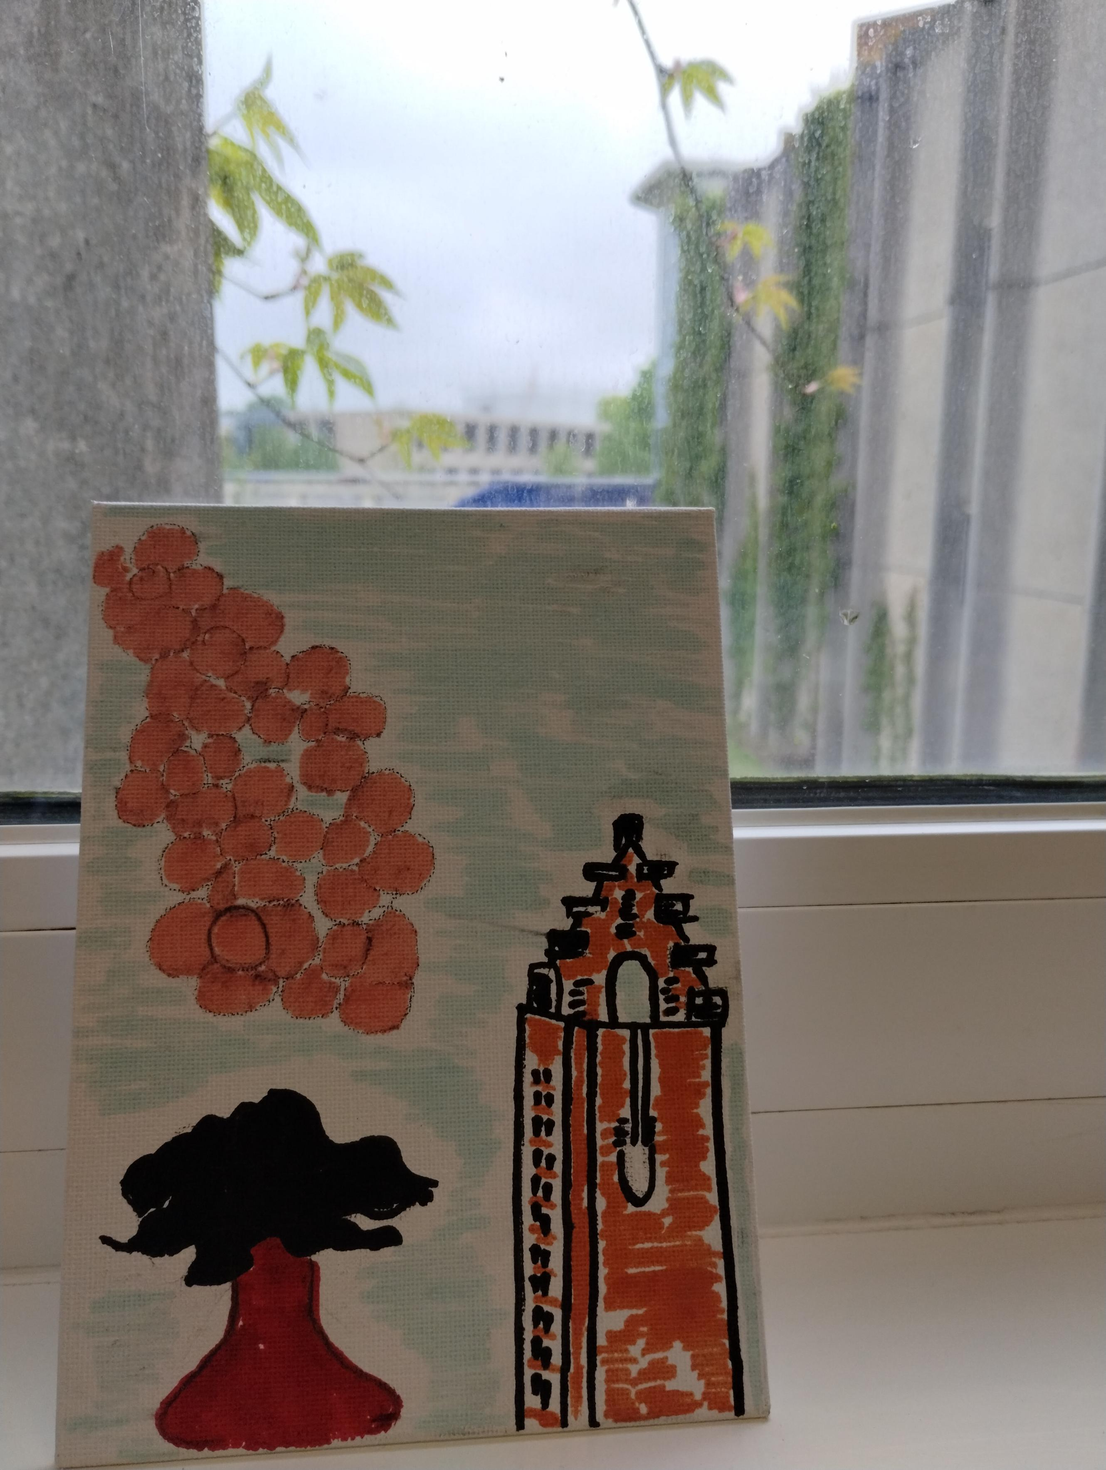

*Self Portrait: The Girl and the National Wallace Monument (Stirling).*

*(Drawn during an Art Session in the Jarman Building, University of Kent).*

**Chapter 2: London**

*Of sounds and spring*

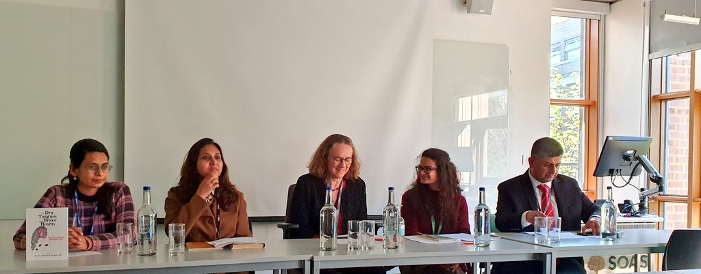

*With Dr. Laura Hammond and fellow Charles Wallace Fellows from India and Pakistan at a Panel Discussion at SOAS University of London*

A few days into the residency, after I was all packed and ready for England for a [Panel discussion at SOAS University of London,](https://www.soas.ac.uk/about/event/panel-discussion-citizenship-and-politics-identity-south-asia)[3] this weird sense of anticipatory homesickness for Stirling started to settle in. I brushed it aside and left for the train station.

London was a total dream- from the intermittent quietude of the Highgate neighbourhood (between cars screeching past our house at odd hours), to the youthful urbaneness of the UCL campus in Bloomsbury, to the lively evening walks with family-like-friends along the Thames, to the vibrant night life between two underground stations or bus stops that we'd often be running between. London in April was as fresh as new love. I found myself writing *ghazals* for the city, like a lover might, while traversing through the London Underground, specifically between the Highgate and Warren Street stations

*An April commutes via tube in London.*

*They say summer is finally enroute in London.*

*……..*

*A liveliness dances on the Tower Bridge,*

*River-winds sing songs of pursuit in London[4].*

As soon as I walked inside the UoS campus after four days, the calm quietude of Stirling hit back with such gentle force... somewhat like the awareness one feels after waking up from a very deep sleep. I fear I am very much in love.

**Chapter 3: Stirling**

*Of heart and hearth*

*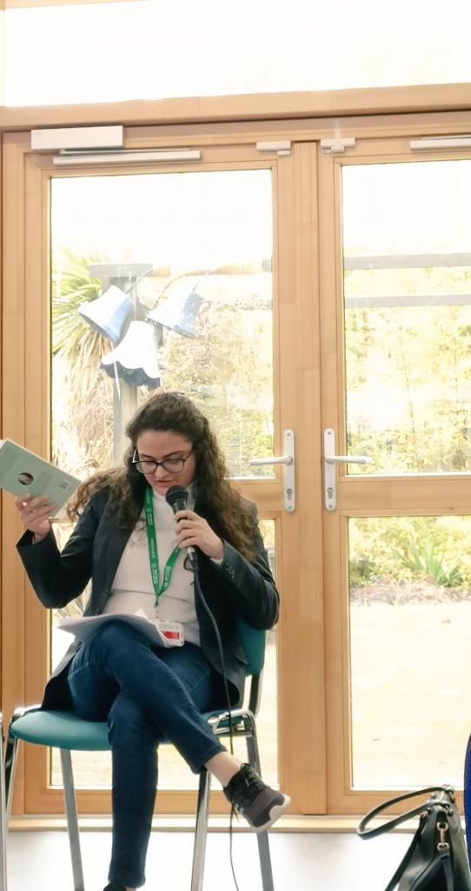A Departmental Reading at the University of Stirling*

The loch at the heart of the University of Stirling campus sort of anchored me even when I was not physically around it. I didn’t even realise when it became the centre of my little universe here – every movement away from it was a soft centrifugal force towards the circumference of the rest of the UK Skyline. I spent hours with the loch, a little diary and pen by my side, observing its ecosystem, [being lost in the formations of the midges](https://soorploompress.com/2023/06/26/ploom-74/)[5] on particularly warm days. This eventually gave birth to a whole [series of loch poems.](https://blog.stir.ac.uk/the-loch-at-the-heart-of-the-university-of-stirling/)[6]

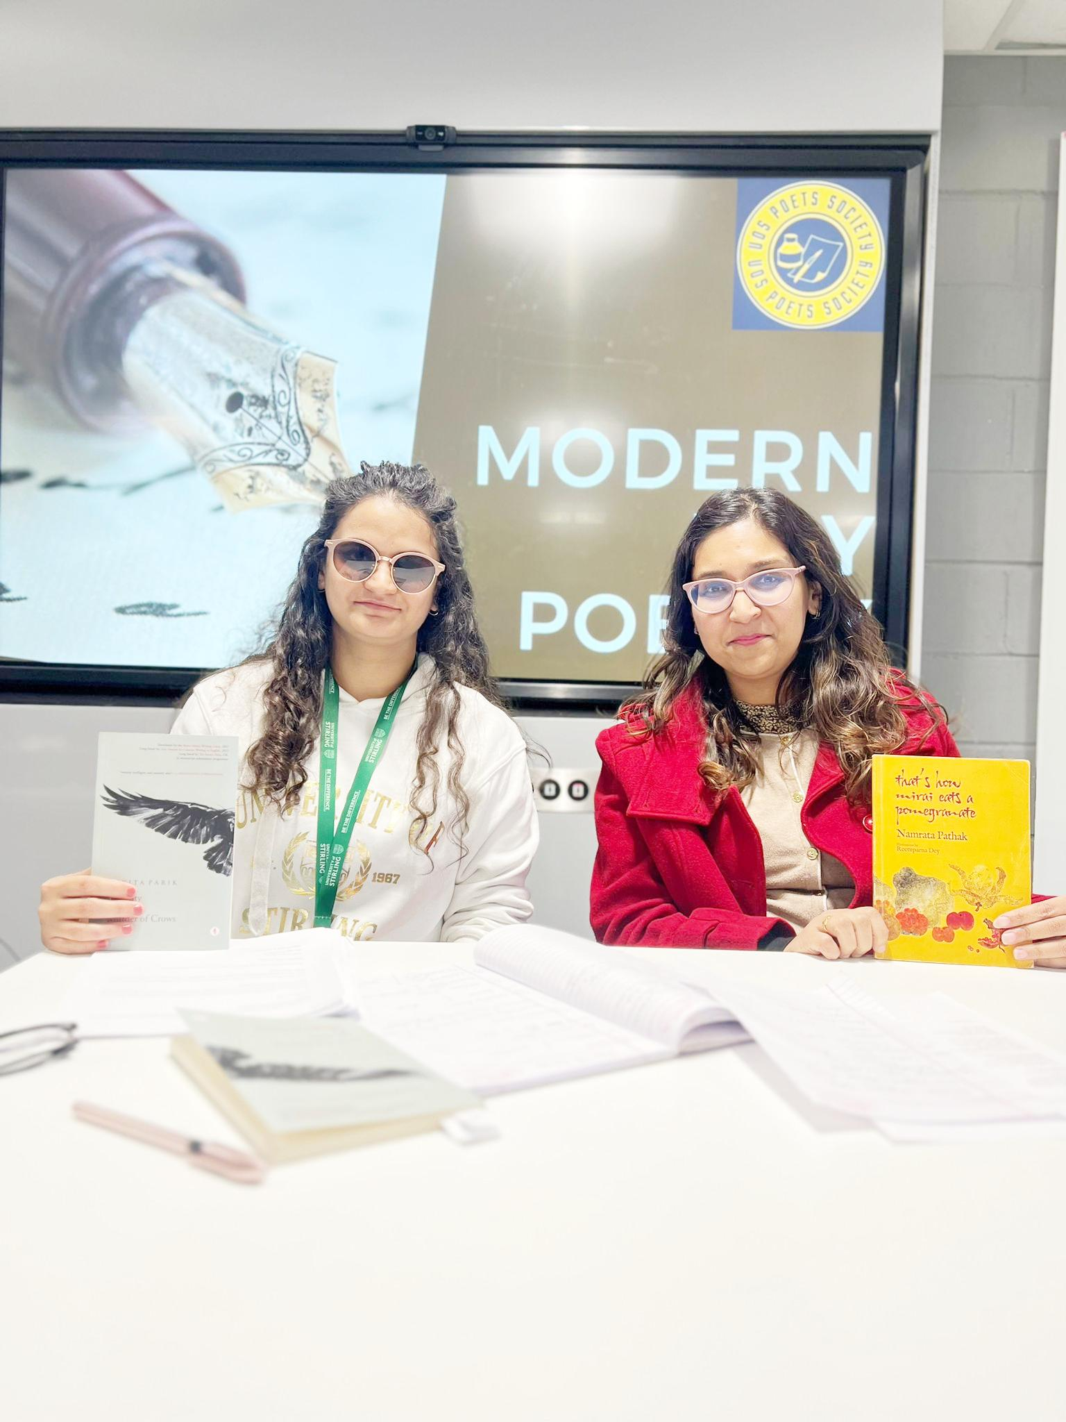

*A special collaborative reading organised by the University of Stirling Poetry Society*

My time in Stirling was filled with constant, consistent inspiration, which led me to ideate and write more than I ever have in one stretch or season. The fellowship months for me translated into plenty of writing peppered with readings, panel discussions, workshops, and collaborative literary experiences across the United Kingdom. When I wasn’t writing, I took to translating the works of my colleagues, or discovering newer Scottish and Irish poets at the wonderfully well-stocked libraries on campus and around the city. In a full circle moment, by the end of my fellowship, it was wonderful to see my books in three libraries across England and Scotland.

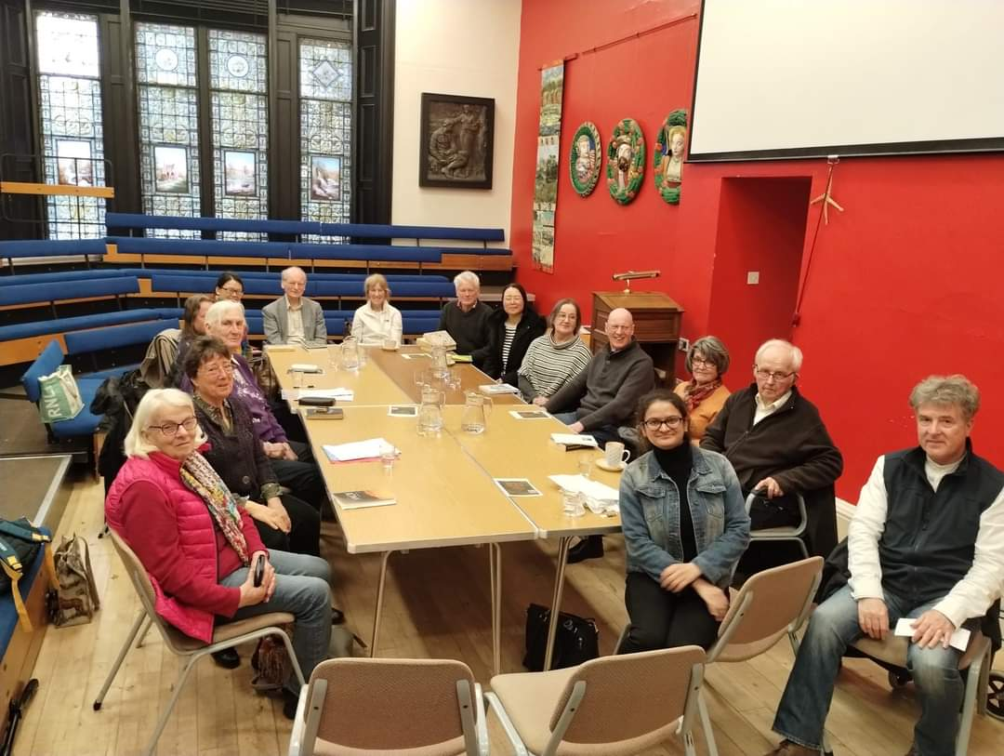

*Reading at the Stirling Smith Art Gallery and Museum*

I wanted to experience the literary landscape of UK through its people, and the inimitable Dr. Gemma Robinson, head of the Charles Wallace Fellowship at the University of Stirling, helped me achieve exactly that. Soon enough, I found myself a part of an ecosystem of academics, students, writers, artists, and just local residents across Stirling (and also the other cities I visited). Apart from [formal university readings,](https://www.stir.ac.uk/events/22-23/art-collection/spaces-and-places-a-reading-with-nikita-parik-and-shreyasi-sharma/) I was part of readings at local cafes, bookstores, historical museums, and libraries, which lead to some wonderful experiences and created friendships that I will deeply cherish forever.

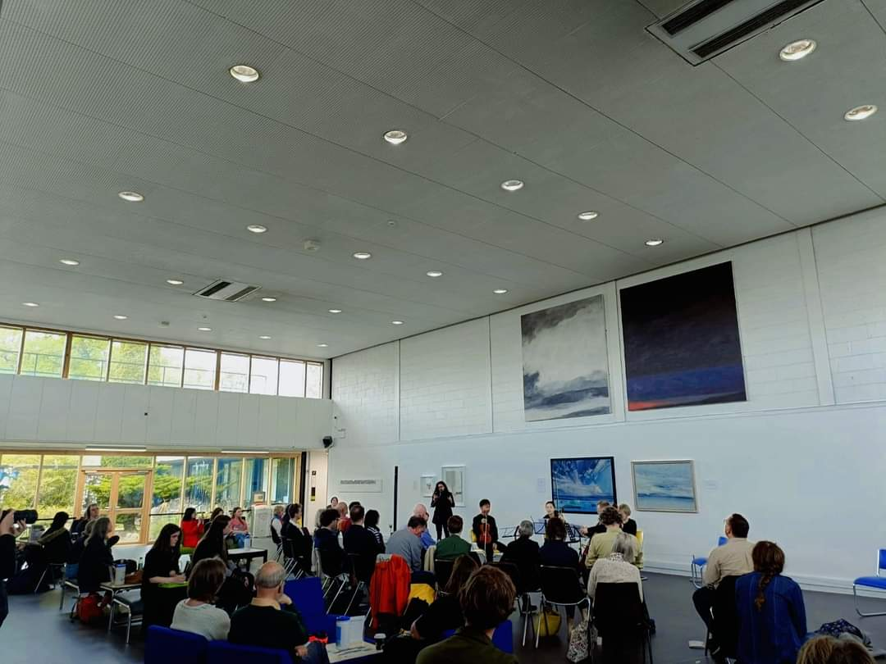

*Reading my House of Words poem at the site of its Installation*

My travels took me to places from Dover to the Scottish Highlands, from the UNESCO City of Literature, Edinburgh, to little English hamlets. Some of the translations I attempted often coincided with how I was feeling.

व्हेल की पीठ जैसी धनुषाकर पहाड़िया, एक बरसता आसमान

ढलते हुए भुर्ज के पेड़ और पथरीली दीवारें

बारिशों मे आकार लेता एक काला पक्षी।

-ग्लेन टाई[7]

As my fellowship period came to a close, it was quite a high to watch a poem of mine being printed from the Pathfoot Press by the amazing Dr. Jackson.

[embed Video: <https://youtube.com/shorts/V6ldEumnMNo?si=j9r0iYm1eKt_2nXt> ]

***Printing Press***

*Wood and metal. Ink and kerosene. Sunlight filtering in from a glass window. And an iridescent, rising stream of dust- loud, LOUD, and ancient. Now an arranging of the elements: wood and metal, paper and ink, until, the loud clack! clack! clack! of a printing machine is heard, erupting, purring, coming to life. An ecosystem seems to be coming together to aid this creation. One holds a piece of beige paper against pools of sunlight: letters- red, black, in bold, in italics. Letters swimming in this off-white universe between perfectly symmetrical lengths and widths. One sighs, then whispers to the nuts and bolts.*

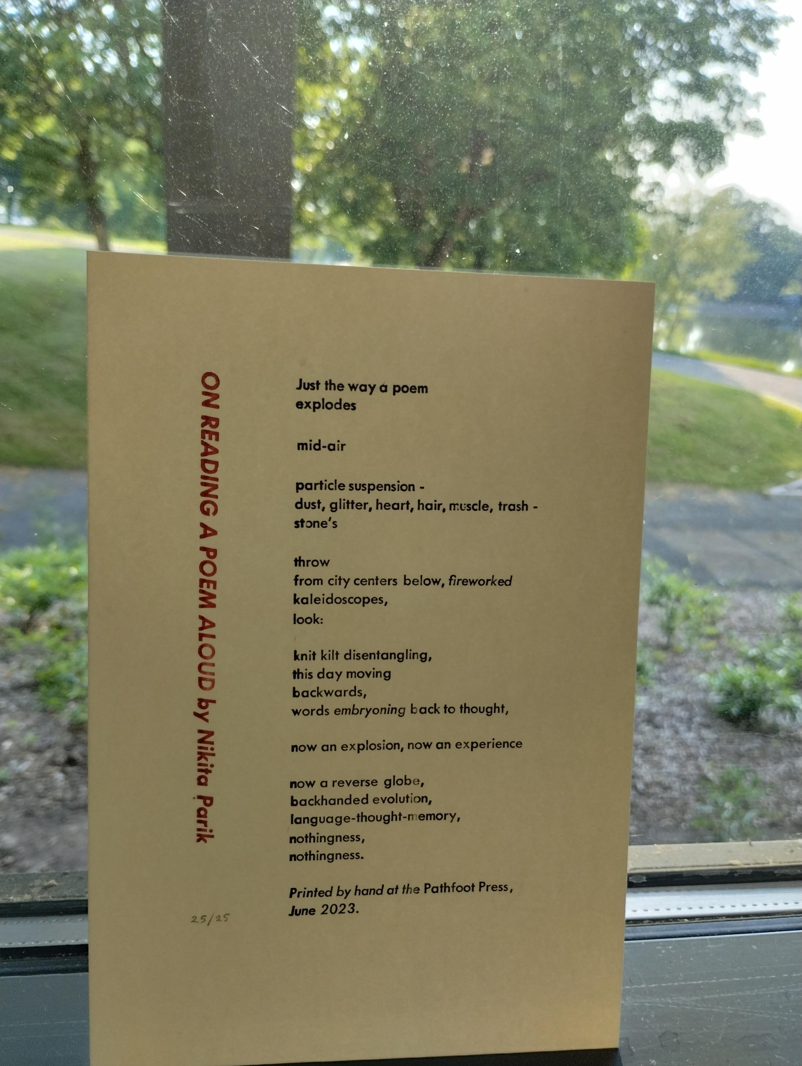

*“Printed By Hand at the Pathfoot Press, June 2023”*

And finally, one of the most rewarding moments of the entire fellowship for me was when my poem went up on one of the glass panes of Crush Hall, Pathfoot Building, for the House of Words installation, and I realised how utterly inseparable I feel from this campus and this city now, like a freshly formed umbilical cord tying me to it for eternity.

*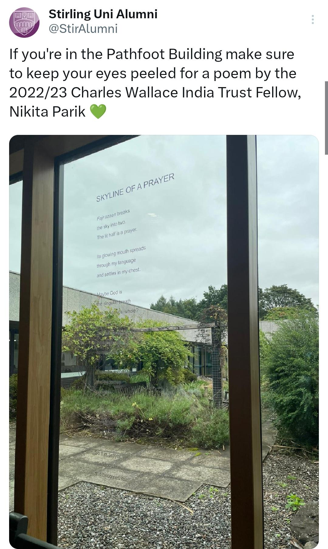X post about my installation from the Stirling Uni Alumni account*

***En Conclusion***

The Charles Wallace Fellowship at the University of Stirling has opened my mind to so much beauty, creativity, and possibilities, and I am deeply appreciative of every single person who crossed my path and made this journey so wholesome. I am thankful to the Charles Wallace India Trust for this opportunity, and to Ms. Shreela Ghosh and the British Council for being there for me every step of the way. Thanks also goes to the departments of *English and Creative Writing* and *Post-Colonial Literature* at the Universityof Stirling for being so welcoming. Much love to all my wonderful colleagues, Gemma, Rowan, Kevin, Chris, Liam, Peter, Fiona, Nina, Louisa, Caroline, and others, for their warmth, friendship, coffee meets, lunches, and conversations.

Thanks to Laura, our Stirling Makar, for her brilliance and kindness, to Anne and John for including us in the wonderful community at Stirling Smith, to Murray for stirring something deep within me that sits at the intersection of archaeology and history, to Jan and the entire community of libraries around Stirling for their warmth and tenderness, to Jennifer, Jack, and the entire Alumni team for being so dedicated, and to the brilliant UoS Poetry Society (Ahmed, Madeline, Tanmay, and James) for their endearing dedication to poetry

Thanks also to the English departments at the Universities of Kent and SOAS for their warmth and support during our collaborative readings, and to my brilliant co-fellows at these two universities, Namrata and Shreyasi, for the way we collectively created history at CWIT fellowships by engaging in these collaborations and forming these incredible spaces for one another, making this fellowship deeply enriching for all of us.

1. Stirling Observer, May 2023
2. University of Kent Blog
3. SOAS University of London Website
4. Stanzas from April in London: A Ghazal
5. Soor Ploom Press, UK
6. University of Stirling blog
7. Original: Chris Powici, from Look Breathe. Translation, Nikita Parik.