Transforming Broomhill: Community Regeneration Evaluation

Isobel Anderson, Trudi Tokarczyk and Cath O’Shea.
February 2019

Table of Contents
Executive Summary 3
Introduction 3
Background to the regeneration 3
Evaluation aims and methods 3
Housing Improvement Works 3
Letting Initiatives, Marketing and Tenancy Support 4
Community Development Initiatives 4
Partnership Projects 5
Outcomes 5
Recommendations for community sustainability and lesson learning 5
Introduction 7
Background 7
Evaluation Aims 10
Evaluation Methods 10
Qualitative discussion groups and interviews 11
Housing Improvement Works 12
Letting Initiatives, Marketing and Tenancy Support 19
Sensitive Lettings Practice 19
Broomhill Court Retirement Housing Model 20
Broomhill Local Housing Office 23
Marketing 23
Community Development Initiatives 24
Community Development Officer 24
Skills development 27
Partnership Organisation Projects 29
RIG Arts – Art Flat and Broomhill Art Project. 29
Broomhill Gardens and Community Hub 30
Infrastructure works (Public realm) 31
Outcomes and Discussion 31
Local identity and belonging 32
Wellbeing and Feelings of Safety 33
Satisfaction with local facilities 33
Resident Voice and influence 35
Learning from Broomhill regeneration 36
Conclusion and Recommendations 37
Effectiveness in addressing regeneration aims, impacts and outcomes 37
Assessment of the overall impact of Broomhill Regeneration 40

Executive Summary

Introduction

This summary presents the key findings of an initial assessment of the ambitious project for community regeneration in the Broomhill estate, in Greenock, Inverclyde. River Clyde Homes commissioned the University of Stirling team to work with regeneration partners to review progress of the Broomhill Regeneration Project. The research was undertaken during August 2018-February 2019.

Background to the regeneration

Prior to regeneration programme, the area was perceived as blighted by deteriorated housing stock, high vacancy rates, and a range of social issues including crime, antisocial behaviour and drug/alcohol related behaviours. Neighbourhood satisfaction was low, but change was sought by the proactive Tenants and Residents Association (Broomhill Tara). Following initial consultations, the programme of more than £20m of regeneration improvements was announced in June 2014. Key partners in the regeneration of Broomhill included, River Clyde Homes, Broomhill Tenants and Residents Association, Inverclyde Council, Riverside Inverclyde and Inverclyde Alliance. The Getting it Right for Broomhill Governance Group (GIRFB) was set up to bring partners together to steer the regeneration project and an ambitious set of community regeneration goals was established.

Evaluation aims and methods

This evaluation sought to ascertain progress towards achieving the GIRFB aims and desired outcomes; provide an initial assessment of the impact of Broomhill Regeneration; and consider longer-term community sustainability as well as lessons learned from the Broomhill experience. The evaluation captured resident and staff experience of the regeneration of the Broomhill Estate in late 2018. The methods adopted for evaluation included familiarisation with the Broomhill Regeneration Project; qualitative discussion groups and interviews with RCH staff, tenants and partner stakeholders; and some integration of available quantitative outcome data.

Housing Improvement Works

An extensive programme of housing refurbishment was completed in Broomhill, bringing stock up to the Scottish Housing Quality Standard (SHQS) and meeting the Energy Efficiency Standard for Social Housing (EESSH). These housing improvement works have underpinned a very substantial and visible transformation of the neighbourhood, which has significantly enhanced quality of living for the residents.
Thermal insulation through the biomass heating system was a key benefit for tenants, contributing to improved health and wellbeing as well as to financial inclusion. Housing Improvement works included extensive internal and external upgrading of properties and common areas, combined with sensitive lettings practice, proactive marketing of the refurbished homes, and the introduction of a retirement housing model at Broomhill Court high rise block. Employment opportunities were also integrated into the refurbishment process with 79 local people employed and 22 training places delivered by the contractor.

The improvement works necessitated a decanting programme, moving tenants to alternative accommodation while works to their home were completed. This proved challenging to implement but tenants were supported by Customer Liaison Officers and lessons were learned during the implementation. For example customer communication was essential and the process of tenants returning to upgraded homes including dealing with damage to decoration and snagging needed to be consistent.
River Clyde Homes subsequently revised and updated their decant policy, taking account of lessons learned in Broomhill regeneration. A benefit of the decanting process was that staff gained significant new knowledge of the situations of vulnerable tenants with complex needs and were able to provide additional support and referral to other agencies, as needed. Tenants reported that this support was invaluable in assisting tenants through the upgrading process.

By the end of the regeneration, Broomhill estate was virtually fully occupied, with clear demand for the refurbished homes. Notably, occupancy of Broomhill Court high rise block increased from 30% to 100% with the introduction of the retirement housing model. The evaluation identified that liaison with property owners on the estate could have been more effective, from an earlier stage. However, benefits in terms of improved selling prices were noted as an outcome of the overall estate regeneration.

Letting Initiatives, Marketing and Tenancy Support

Alongside the housing improvement works, RCH implemented important changes to lettings practice and designed a proactive approach to marketing the newly refurbished properties. A sensitive lettings initiative allowed flexibility in scrutinising applications to change the overall tenant profile in order to support tenancy sustainment in a more diverse community. Sensitive lettings practice was also highlighted as an important contributor to lowering levels of crime, and improvements in tenancy sustainment in Broomhill

A retirement housing model was introduced into Broomhill Court High Rise block, with enhanced management (retirement housing co-ordinator post), improved security, a community flat (Suite 16) and a guest room. The model delivered high quality accommodation for older people combined with a programme of social and community activities to tackle issues of isolation which had been identified.

The Broomhill Local Housing Office opened in February 2015 and has been a focal point for residents during the regeneration works and for new customer housing enquiries. This base enabled staff and partners to be more visible in the community and to get to know their customers better. The central location on the estate had been crucial to developing links with the community for implementation of regeneration interventions, as well as for promoting community cohesion and wellbeing.

RCH’s marketing and communication strategy combined use of lettings flyers and show flats with utilising social media, a web page and local newspapers to communicate the changes across Broomhill.

Community Development Initiatives

The Community Development Officer post was crucial in coordinating a range of community activities bridging the housing and community aspects of the regeneration programme. Community activities focused on social and skills development opportunities, bringing residents together and attracting people from beyond Broomhill.

Partnership Projects

The RIG Arts/Arts flat project was a significant and innovative initiative to bring creative arts to the community in order to enhance social cohesion and build resident confidence and transferable skills. More than 500 activities were delivered with over 3000 places taken up across the four years of activity to date. The project has already been recognised as best practice and innovation in community regeneration,
winning a Scottish Urban Regeneration Forum (SURF) Regeneration Award in 2017.

The Broomhill Gardens and Community Hub opened in October 2017. This partnership between Inverclyde Council and Inverclyde Association for Mental Health (IAMH) was also supported by Broomhill Tara. It provides headquarters for IAMH plus a café and community hall. The Hub contributes to bringing people into Broomhill and providing employment/skills for local people via their subsidiary company In-Work.

Outcomes

Evaluation evidence suggests that the regeneration of Broomhill has contributed significantly to revitalising community identity and a sense of belonging for residents. Feelings of wellbeing and safety have been enhanced and participants were generally satisfied with local amenities and facilities. There was a strong sense that crime and antisocial behaviour had significantly reduced. Resident involvement was recognised as having contributed significantly to the design and delivery of the regeneration.

Learning points from the Broomhill regeneration included the need for a co-ordinated project plan; regular communication across all partners; and a consistent joined up approach to delivery. Future projects should have clear process for decant, for completion of snagging on properties and for conveying information on key changes (e.g. different central heating system). It was recognised that the local office was key to delivering the regeneration programme with staff being visible and accessible in the area.

Potentially transferable elements of Broomhill regeneration included having a base in the community, working together as a team and putting customers at the heart of the project. Sharing knowledge and information within the organisation, including measuring performance and celebrating success were also recognised as organisational benefits.

Overall, the evaluation found substantial evidence of action to address the extensive GIRFB goals. Progress towards meeting these goals was particularly significant in relation to empowerment and working closely with residents; reducing antisocial behaviour and perceptions of crime; and delivering partnership working. The physical upgrading of the housing stock crucially underpinned the social and community regeneration interventions.

Recommendations for community sustainability and lesson learning

- Seek a mechanism to retaining presence on estate (achieved through local housing office)
- Seek a mechanism to continue to co-ordinate and support community development activities (achieved through Community Development Officer post)

- Ensure completion of remaining environmental works and road improvements support longer term sustainability
- Identify opportunities to provide and maintain more open space and play areas in the neighbourhood.
- Build on the lessons to date to ensure enhanced planning for future housing improvement works, including decanting and snagging procedures.
- Ensuring enhanced engagement with owners of sold properties and any other residents who are not tenants of RCH.
- Consideration opportunities to attracting younger age groups to the area, including families with children, and ensure their inclusion in community development activities.
- Continue to support the achievements in resident and tenant support in the neighbourhood, including support for continuing role for Broomhill TARA
- Some continued financial investment is likely to be required to ensure the sustainability of the completed regeneration. Full transferability to other locations would depend on similar levels of resources.
- Across all partners, what can realistically be achieved in terms of wider social and economic goals, within structural constraints of embedded disadvantage and resources available to tackle structural and area based inequalities.
- Disseminate summary learning materials across partners and the wider regeneration sector to ensure lessons learned are widely shared. The combination of community and physical regeneration was key to success.

Introduction

This report sets out the findings of an initial assessment of the progress and impact of the ambitious project for community regeneration in Broomhill, a compact social housing estate in the town of Greenock in Inverclyde. The regeneration project was jointly led by registered social landlord, River Clyde Homes (RCH) and the local authority, Inverclyde Council. As the regeneration neared completion, River Clyde Homes commissioned this evaluation to document and analyse key achievements and challenges, providing an independent overview to support local monitoring of the regeneration outcomes. River Clyde Homes commissioned the University of Stirling team to work closely with staff, tenants/customers and partners to develop a robust review of its Broomhill Regeneration Project. The research was undertaken during August 2018-February 2019.

Background

A number of key partners contributed to the development and implementation of the Broomhill estate regeneration. River Clyde Homes owns and manages over 5,800 homes and provides factoring services to a further 2,200 homes in the Inverclyde area. Formed in December 2007, following the transfer of homes from Inverclyde Council, they are a registered charity, monitored and regulated by the Scottish Housing Regulator. The local tenants and residents association (TARA) in Broomhill was closely involved from the inception stages of Broomhill Regeneration. Inverclyde Council provides a range of services to residents and businesses, including strategic planning for housing. Along with Scottish Enterprise, Inverclyde Council set up Riverside Inverclyde (ri) as an Urban Regeneration Company limited by guarantee, with charitable status. As a public/private partnership, ri was designed to secure the long-term economic growth of Inverclyde. The local authority also co-ordinates the multi-agency community planning partnership for the area – Inverclyde Alliance.

Broomhill comprises some 561 dwellings - 434 RCH social rented homes and 127 privately owned properties which receive a factoring service from RCH. The stock is mainly post-war system built flats including three multi-storey blocks (Whinhill, Prospecthill and Broomhill Courts), and a number of adjacent blocks of lower rise flats. Local residents and agencies acknowledge that over the previous 15-20 years, Broomhill had developed a very negative image. The area was perceived as blighted by a range of issues, including, high vacancy rates, social issues relating to drug/alcohol use, anti-social behaviour and crime.

Pre-regeneration, there were more than 200 long-term vacant (void) properties on the estate, equating to a 40% void rate. Some properties had been empty for 12 years or more. The estate was not only characterised by inadequate housing, but also experienced a negative reputation related to perceptions of high levels of crime and drug and alcohol misuse. Neighbourhood satisfaction levels were consistently low but Broomhill benefited from a very active and productive Tenants and Residents Association.

Following early consultations, River Clyde Homes, Broomhill TARA, Inverclyde Council and other partners committed to restoring the Broomhill area of Greenock to a high demand neighbourhood with excellent quality housing. In 2013, a masterplan for the Greenock Central East area was prepared and subsequently approved by the Council in 2014. The masterplan included Broomhill area and provided the context for development, identifying opportunities for longer-term investment with the aim of improving the overall environment. The master plan included the physical upgrading of all of River Clyde Homes’ housing stock in Broomhill, plus the installation of a biomass

heating system. The masterplan also included key infrastructure works (notably the re- alignment of nearby Bakers Brae, a key access route to Broomhill) and identified development sites for new housing, industrial sites, open space provision and green network enhancements. On 5 June 2014, the £20m regeneration project was announced.

Subsequently, the Getting it Right for Broomhill Governance Group (GIRFB) was established as a result of Inverclyde Alliance’s desire to use Broomhill as a pilot for an asset based approach to community development. A key priority for the GIRFB approach had been to improve outcomes and reduce inequalities for those living in Broomhill, making Broomhill a desirable place to live. This group had overseen the regeneration process but was no longer active at the time of the evaluation. However, the aims and outcomes for Broomhill Regeneration had been further developed into a more detailed document: Getting it Right for Broomhill Governance Group: Aims and Outcomes 2017-2020 (River Clyde Homes, 2017) which has been a key reference document for the evaluation.

While improved housing quality underpinned the Broomhill regeneration project, the Getting it Right for Broomhill Governance Group agreed a broader set of aims for the neighbourhood. Consequently, River Clyde Homes sought to:

- Work even more closely with communities and residents to further involve the public in the design and delivery of the services they use (co-production)
- Identify and harness all the assets available in a community to help deliver positive outcomes
- Support families/households to help themselves and reduce dependency
- Support more families/individuals into employment and into good quality, sustained work
- Improve levels of physical and mental health
- Reduce drug and alcohol misuse
- Reduce levels of reoffending and antisocial behaviour
- Support families with children to achieve more
- Build on existing partnership working to enhance integrated services and improved outcomes.
- Look for opportunities to reduce duplication, better use resources and share services (public, third and private sectors).
(River Clyde Homes, 2017, 2018).

From an early stage, it was anticipated that the regeneration investment at Broomhill would bring about wider benefits, beyond physical improvement of the housing stock. From the outset, the involvement of local residents (including tenant members of RCH Board) and workers, in recognising the need for, and developing, service re-design was core to the regeneration approach. There was also a desire to increase early intervention with residents and so reduce demand on services. Delivering a whole system perspective to regeneration sought to remove duplication and waste in service provision.

The regeneration initiative sought to achieve ambitious outcomes for the Broomhill community including:
- Nurturing an empowered and sustainable community
- Increased wellbeing and reduced inequalities
- Increased feelings of safety
- Increased financial security through employment or better access to support and advice services

- Greater social inclusion of families
- All children to have the best start and improved opportunities in life.

Getting it Right for Broomhill Governance Group: Aims and Outcomes 2017-2020, set out key actions to achieve these goals and possible measures of success.

Evaluation Aims

The purpose of the research was to evaluate the initial impact of the Broomhill Regeneration programme and to make recommendations for monitoring its longer- term impact and sustainability. The study sought to ascertain progress towards achieving the GIRFB aims and desired outcomes. The research team took a partnership approach, working collaboratively with River Clyde Homes and other stakeholders.

This report on the regeneration of Broomhill offers practical insights that can inform work with local communities about regeneration, planning and management, as well as reporting on residents’ experience of the process. The research focused on residents’ knowledge and feelings about the regeneration plans and what mattered most to them; how people felt about the changes in the neighbourhood; how they described their own wellbeing and local social relationships; and levels of satisfaction with housing and other local facilities. The study also heard the views and experiences of professionals involved in delivering the regeneration programme. The evaluation captured resident and staff experience of the regeneration of the Broomhill Estate in late 2018. Physical regeneration of the housing stock was complete, with key community activities ongoing and environmental and infrastructure works still underway.

In making an initial assessment of the impact of the Broomhill Regeneration programme, the evaluation sought to:
- examine how effectively the agreed regeneration aims, impacts and outcomes had been addressed
- provide an initial assessment of the overall impact of Broomhill Regeneration
- make recommendations for longer term monitoring of sustainability, and for transferring learning to other projects.

Evaluation Methods

The study adopted a partnership approach that enabled evidence gathering to respond to data availability and to discussions with, and suggestions, from RCH staff during the evaluation period. In developing the evaluation, the team worked closely with RCH staff and other stakeholders who had comprised the Getting it Right for Broomhill Governance Group (GIRFB).

The main methods used to evaluate the regeneration project were:
- Contextualisation and familiarisation with the Broomhill Regeneration Project through initial meetings with key staff and review of available documentation.
- A series of qualitative discussion groups with RCH staff, tenants and partner stakeholders about their experiences of the regeneration project (housing and community dimensions). A small number of individual interviews (some by

telephone) were conducted with participants who were not able to attend discussion groups.
- Integration of available quantitative and benchmarking data for key aims and outcomes.
Contextualisation
The team reviewed a range of RCH documentation on the regeneration process and met with key staff to agree on implementation of the evaluation, including agreeing an expanded list of potential stakeholder participants and an increased emphasis on qualitative data collection through group discussions and interviews.

The key source documents provided by RCH included:
  - Getting it Right for Broomhill Governance Group: Aims and Outcomes 2017- 2020 (River Clyde Homes, 2017) – referred to below as GIRFB 2017-2020 document.
  - Broomhill Regeneration (RCH Community Development Officer, 2018) – key information on physical regeneration; GIRFB Governance; Tenants and Residents Association (TARA); Community Development Officer (CDO) activities; Rig Arts Art Flat and Broomhill Art Project; Broomhill Gardens and Community Hub; Bakers Brae road realignment and Community Hub
  - Broomhill Area Reassurance Initiative (Inverclyde Community Safety Partnership, 2016, 2017) – Report and presentation on use of Place Standard tool to assess the needs of the Broomhill Community, and referred to as the Place Standard Exercise in this evaluation report.
  - Information from the RCH event ‘The Broomhill Experience – Lessons Learned’, which team members attended.
This report draws on these documents for detailed accounts of the Broomhill Regeneration Project and related activities. The materials also informed the qualitative data collection.

Qualitative discussion groups and interviews

The qualitative stage of the research was conducted in October and early November 20I8, and achieved a good response to invitations to participate. The aim was to capture a range of perspectives and insights that could add depth to the study. The semi-structured, 60-90 minute sessions were carried out either in groups, face-to-face, or by telephone. These included conversations with tenants, residents and community activists (mainly long-term residents) and a number of local stakeholder organisations and service providers based in, or supporting people living within, Broomhill. Six core discussion groups were held with the following participants:

- RCH Broomhill Housing Staff
- RCH Broomhill Regeneration Project Staff
- Broomhill Court Tenants
- Broomhill Tenants and Residents Association
- RCH Managers
- Stakeholders from partner organisations

In addition, some telephone interviews were conducted with property owners in Broomhill, who received factoring services from River Clyde Homes. In summary, interviews/discussions took place with almost 40 participants:
- 12 tenants and residents of Broomhill
- 8 members of the Broomhill Tenants and Residents Association (TARA)
- 11 River Clyde Homes staff (including three managers)
- 7 partners/stakeholders (including representation from Inverclyde Council Community Safety and Resilience team, Inverclyde Council Public Health and Housing team, Riverside Inverclyde, CVS Inverclyde, Police Scotland, RIG Arts and Inverclyde Association for Mental Health staff.
The discussion groups were fully transcribed and analysed thematically for this report. Conversations explored how much people knew about the regeneration plans and what mattered most to them; levels of satisfaction with housing; how people felt about the changes in the neighbourhood; how people described their own wellbeing and local social relationships; and views on local facilities. Overall, the qualitative data collection benefited from positive participation from residents and professionals, yielding rich qualitative information. In the findings sections below, qualitative data is summarised thematically and blended with illustrative quotations from participants. No participants are individually identified and quotations are only attributed to the relevant participation group (e.g. resident, staff, and stakeholder).

The evaluation was conducted in accordance with agreed standards of good practice laid down in the Economic and Social Research Council’s Framework for Research Ethics and the University of Stirling’s formal procedures for research integrity and ethics. These adhere to six principles of: ensuring integrity, quality and transparency; providing full information about the purposes, methods and uses of research; respecting confidentiality and anonymity; voluntary participation; avoidance of harm to participants; and independence of research with all conflicts of interest or partiality made explicit. These principals apply equally whether working with members of the public or with professionals in client or partner organisations. Ethical approval for the study was confirmed by the University of Stirling General University Ethics Panel
(GUEP) on 24 September 2018. The research was also undertaken in accordance with the University of Stirling GDPR Policy.

The remainder of the report sets out the findings and recommendations from the evaluation. Our analysis combined material from workshops with local tenants and residents, the review of documentary evidence and available quantitative data to develop an overall assessment of the regeneration programme. Analysis sought to build a picture of the strengths and achievements of the housing regeneration and wider community activities, as well as aspects where delivery could have been more effective and lessons learned for the future. Recommendations are also made for longer term monitoring of the sustainability of Broomhill and on transferability of lessons learned to other projects.

Housing Improvement Works

A critical element of the regeneration of Broomhill was the physical regeneration work to improve the housing stock. Since 2015, £30 million has been invested to bring the housing stock up to the Scottish Housing Quality Standard (SHQS) and Energy Efficiency Standard for Social Housing (EESSH). Following these improvements, all

properties in the regeneration programme do now meet the Scottish Housing Quality Standard and are EESSH compliant. Additionally, since 2015, over 102 housing units that were no longer fit for purpose have been demolished. Community support and activities were also critical to the regeneration programme through the wider GIRFB aims. The TARA led on an asset based community development approach to ensure a sustainable community for future generations. The housing improvement works have clearly underpinned a very substantial and visible transformation of the neighbourhood which has significantly enhanced quality of living for the residents.

The physical regeneration works included the following improvements to all 434 RCH homes:
- New kitchens, bathrooms and full electrical rewire of all properties, necessitating a decant programme for 341 tenants and families into temporary accommodation while these works were completed
- New double glazed windows and doors
- Communal windows and doors
- Controlled entry doors and systems
- Improved drainage, gutters and downpipes
- Full decoration and carpeting in low demand properties
- Landing decoration
- Refurbished foyers in high rise blocks
- A new retirement housing model in Broomhill Court
- A new community facility at ‘Suite16’, Broomhill Court
- New roofs
- External Wall Insulation
- A new Biomass District Heating system
In addition an agreed demolition programme of 60 properties in 2016 and a further 42 properties in 2018 was completed. Environmental works which were still to be completed at the time of the evaluation included environmental landscaping and improved open space.

A 14 month decanting programme was required to deliver the housing improvement works. Supported by two dedicated Customer Liaison Officers, 23 decant flats were used for temporary accommodation for 341 tenants and families while their main homes were refurbished. Weekly decant meetings with the Project Team enabled identification of the customer profile and any vulnerable customers who might need special assistance. Tenants were also signposted to other services as needed and tenancy sustainment services were put in place.

Qualitative evidence collected for the evaluation suggested that residents were generally satisfied with the improvements made. There was wide acknowledgement that the physical regeneration of the housing stock had greatly improved residents’ physical health and wellbeing. Residents reported that their homes were warmer and that this has greatly improved their sense of wellbeing.

One member of staff commented:
I think from a poor, deprived area that it was, it’s dramatically changed... Nobody wanted to come and stay here. It looked a mess. You drove up and down there was no lights on. Now there’s lights on all the time.

While a tenant confirmed:
“I warm my house up and then I turn the heating off and it stays warm… It’s cool in the summer and warm in the winter because of the cladding.”

In the discussion groups, staff reflected on the housing improvement process which involved ‘decanting’ tenants to alternative properties while their homes were upgraded. During this process staff found they were required to engage much more fully with tenants and residents with whom they had little or no previous direct contact. As a result, they got to know the community better and became aware of vulnerable tenants who required additional support. Customer Liaison Officers provided crucial support to residents, providing everything from practical assistance and support during the decant process to referrals to third sector agencies and services where necessary. During the decanting process, staff identified residents living in challenging circumstances and experiencing problems with their tenancy which had not come to light until commencement of the regeneration and decant process. It was only when frontline

staff began to work directly with the tenancies that the full extent of such cases became clear. Some tenants were rehoused permanently, for example if their original flat was no longer suitable, thereby avoiding further disruption.

We kind of feel as if we’re social workers, housing officers, police officers sometimes the police wardens, like everything. (Staff)

I definitely think we touched a good few peoples’ lives for the better with flagging up the need for special support because a lot of people don’t see anybody at all so it was only when we were going in that you became aware of any problems. (Staff)

Lettings practice allowed current tenants in Broomhill to move permanently to a different property within the area, so avoiding the decant process. Some people chose to move to higher floors or to move out of high rise into low rise properties.

Broomhill residents were also asked about how they felt before and after moving to their upgraded home. There were some mixed feelings about the process with tenants who were decanted reporting significant upheaval and delays to their return home.
However, tenants noted that River Clyde Homes did learn from their experience and as the project developed these issues became less significant.

… but I just think the lessons they learnt from Whinhill Court [the first block refurbished], they ironed it out; about decanting people, how to put them into a building, you know (Resident)

Frontline staff and managers involved in the project also acknowledged that the effort involved in moving and decanting tenants had initially been underestimated. In particular, RCH had not anticipated the number of customers who would require additional support (e.g. due to age, frailty or poor mental health). However, Customer Liaison Officers were in post from the outset of the kitchen, bathroom and rewiring works. Tenants and staff all reported that this role provided significant support, with staff often going ‘above and beyond’ their core job to assist customers in the decanting process.

Both tenants and staff reported that they had not been fully prepared for the significant amount of damage that the internal upgrading work would cause to property decoration. Some tenants were also unhappy with the snagging process on moving back in to their homes, reporting delays in issues they raised being dealt with. The damage caused by upgrading works also had a financial impact on tenants who found themselves having to completely redecorate their home on return. RCH did provide paint packs as compensation to tenants. However, the process appeared to lack consistency with some tenants receiving more substantial compensation than others. Tenants and staff commented that for future projects there should be a clear policy that should be adhered to in these circumstances. Another idea to emerge was that future programmes could have a demonstration flat for tenants to get an idea of how the completed works would look. River Clyde Homes subsequently revised and updated their decant policy, taking account of lessons learned in Broomhill regeneration. They also used show flats in marketing the refurbished properties to new tenants.

Another feature of the physical improvement works reported by residents and staff was the level of disruption in the local area with contractors on site over a period of years (including impacting on parking). For example, participants commented that the estate was like a building site, with noise affecting some people’s mental health to the extent

that they were offered alternative day time accommodation because of the noise level around them.
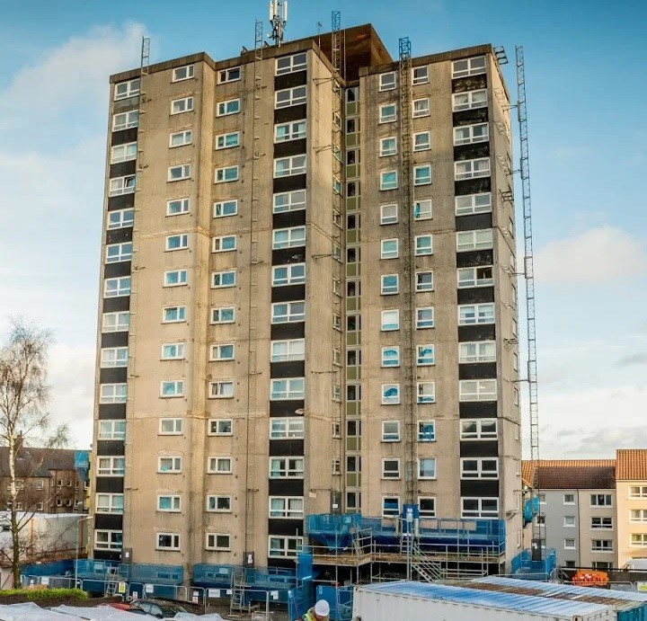
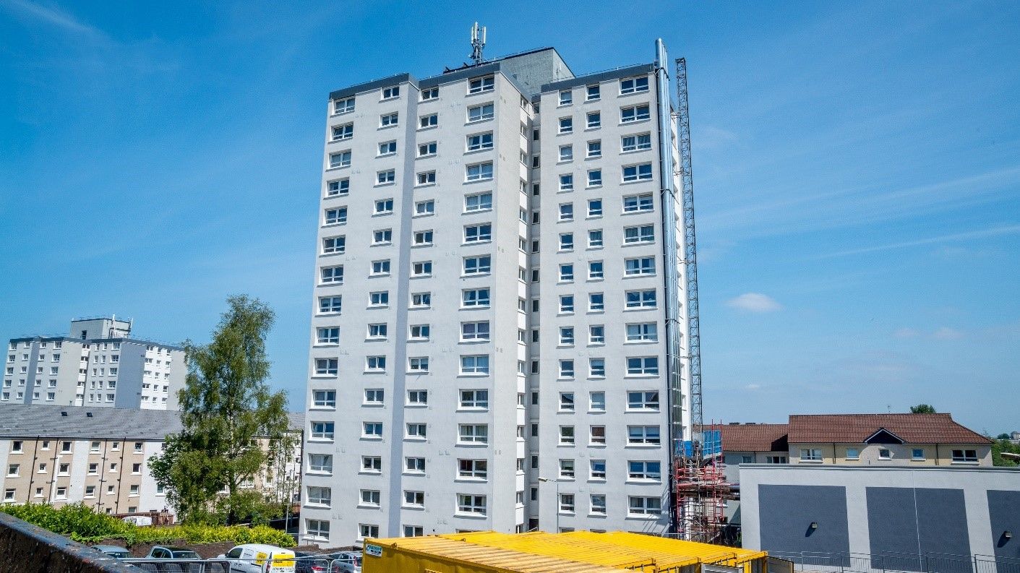

Staffing issues during the refurbishment programme also featured in the participant discussions. Some staff commented that the turnover of staff in the contractor firms contributed to disruption and delays to completing the improvement works. Tenants, residents, housing staff and key partners all reported that at times, changes in RCH staffing structures led to some inconsistency in project management, again contributing to disruptions and delays in the regeneration process.

Notwithstanding the challenges of delivering on a complex and substantial capital improvement programme, implementation facilitated economic opportunities for local residents.

Figure 1: Employment and training opportunities within the refurbishment programme

Employment of 79 local people and 22 training places

A specific issue identified was the relative lack of investment in privately-owned ex- council properties sold through the Right to Buy legislation (prior to its abolition in 2016). River Clyde Homes was no longer the landlord for these properties and a proportion had subsequently become privately rented (rather than owner occupied). Property owners in the Broomhill area were less positive about the regeneration process than other tenants and residents. The owners who took part in the study did not have complete trust in the lead stakeholders, possibly as a result of a lack of adequate consultation for this group of residents. Engagement and general communication with owners could have been more effective throughout the regeneration programme. However, owner occupiers were also seeing the benefits of the completed improvements to the area with a positive impact on properties selling on the open market at home report value.

For me to see houses now selling in Broomhill is good because we had a danger of landlords moving in, taking these properties at low values, so that’s been really positive and we’ve seen a sell on since (Staff).

Tenants, residents and housing staff highlighted that the overall success of the regeneration required the remaining environmental and road improvements (below) to be completed. There was some concern that without continuing investment in completing and maintaining external environment works, the overall regeneration project would be incomplete.
Figure 2: Broomhill Estate
Quality Standards on completion of housing improvements

100% EESSH Compliant

100% SHQS Compliant

Biomass central heating providing savings of 60% on average, per household - £350/£400 per annum

RCH conducted a customer satisfaction survey through an independent consultant which achieved (37 responses out of a sample of 100. The survey found that respondents were most satisfied (scoring more than 6 or more out of 10) with: the information they received in advance of the refurbishment programme; new kitchens and floor coverings; notice of their move to a decant flat; satisfaction with their decant flat; and the ease of contacting Customer Liaison Officer. Tenants were less satisfied (scoring 5 or less out of ten) with the time taken to complete works; issues with completed works (e.g. damage due to works), resolving snagging issues and the decoration pack.

What stood out from some discussion workshops was the commitment of the Customer Liaison staff involved in decanting tenants with various and sometimes complex needs.

The workers wouldn’t go in so we went in with rubber gloves, the two of us and scrubbed (Staff)

We just cleaned it so that… You see going back to someone with mental health issues and saying you need to clean that, how’s he going to know what to do? I think that’s where he was kind of stuck. We just said, ‘look do you think we can come in and do it’ (Staff).

you all deserve a medal for what you did (Staff)
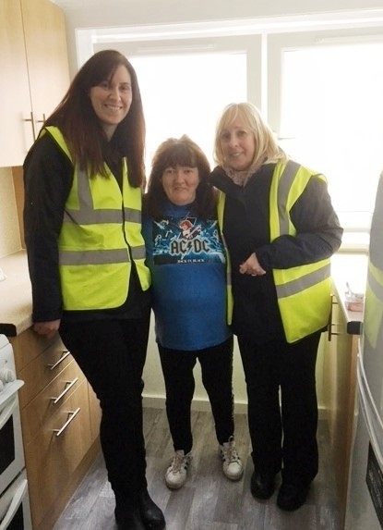

It was clear that a huge amount of experience and knowledge was gained by RCH staff in delivering a large regeneration project providing invaluable learning for future projects.

This is the biggest thing we’ve done. There should be some sort of portfolio of information (Staff).

They’re all chuffed because our place is looking brilliant. I mean it’s delightful to go into our building now isn’t it?’ (Resident)

We’ve taken it for granted now and I think we also took it for granted that the windows leaked and the wind blowed. And you thought ‘oh for goodness sakes

I’ll put heavier curtains up’, or I’ll move my candle, obviously not beside the curtains but away from the draft and things like that and we just take it for granted that we don’t have that any more. (Resident)

Letting Initiatives, Marketing and Tenancy Support

Alongside the physical upgrading of the homes in Broomhill, River Clyde Homes implemented a proactive plan to tackle low levels of occupancy and some of the challenging social issues in Broomhill. A number of changes to lettings practice were introduced in parallel with positive marketing of the refurbished properties and support for tenants during and after the refurbishment process.

Sensitive Lettings Practice

A sensitive lettings plan was introduced to Broomhill to enable a balanced selection of tenants; ensure an appropriate fit between property and new tenant; and to encourage applicants to actively move into the area. Properties continued to be let through the Choice Based Lettings system, but given the challenges faced in Broomhill prior to regeneration, the sensitive lettings policy enabled some management of bidding from applicants in order to achieve a more balanced tenant profile. The aim was to encourage a wider pool of residents to come and live on the estate. In addition, the sensitive lettings plan enabled existing tenants to move within the Broomhill area to an empty property of their choice, where they wished to remain in the neighbourhood.
The initiative allowed housing officers to scrutinise applicants known to have previous tenancy management issues. This was based on the need to ensure Broomhill became a sustainable community and to support tenancy sustainment.

We’ve got a situation at the moment, it’s a young person bid for a property and we’ve looked at all the circumstances. There’s no reason not to offer that boy
that property. But what we’re going to do is, we’re probably going to put intensive support in for him, so that he can actually sustain his tenancy. Because housing really is up here, apart from if you’re going to move into sheltered or housing with care or whatever, but there is really housing from the cradle to the grave up here because there’s all different types (Staff).

Fig 3: Lettings outcomes - Broomhill

Broomhill Estate Occupancy at Nov 2016 – 45% Broomhill Estate Occupancy at Nov 2018 – 98%

70% of lets to new customers

Broomhill Estate Void Loss Nov 2016 - £62,970.72 Broomhill Estate Void Loss Nov 2018 - £3800.07
Source: RCH.

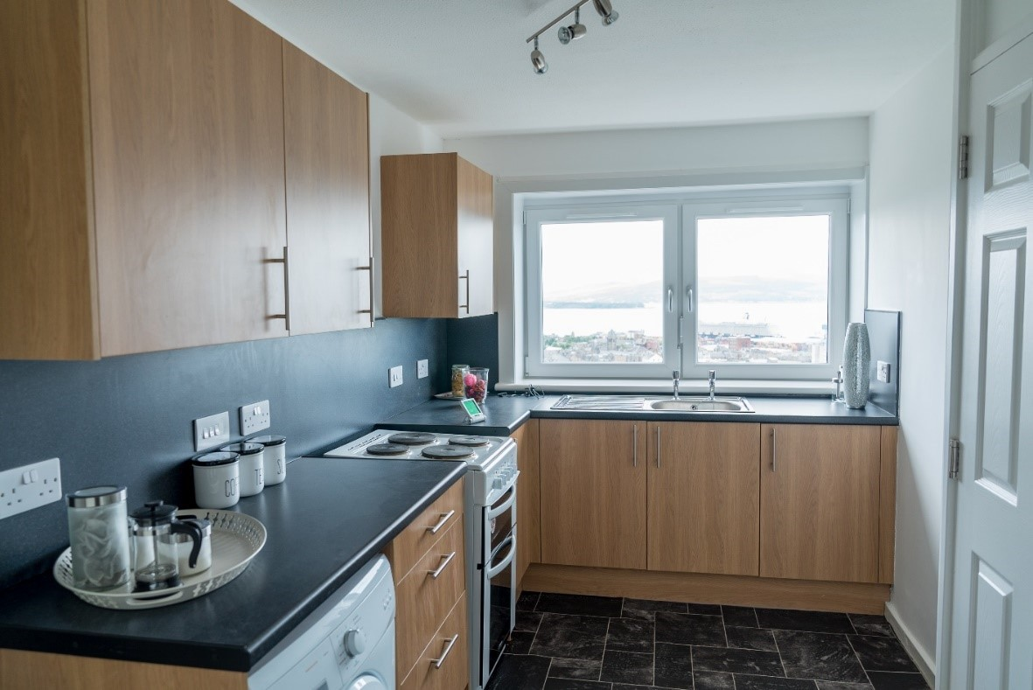

Broomhill Court Retirement Housing Model

River Clyde Homes introduced a new Retirement Housing model at Broomhill Court high rise block, encouraging lettings to older age groups and providing enhanced support through a retirement housing co-ordinator for the block. The retirement housing provided an enhanced housing management service to older people who require assistance to live independently, enabling elderly residents to feel safer and more secure within their home. Besides the retirement housing coordinator on site to look after the block, services included increased CCTV, a call point in the foyer, guest apartment facilities and the community suite (below) with regular activities.
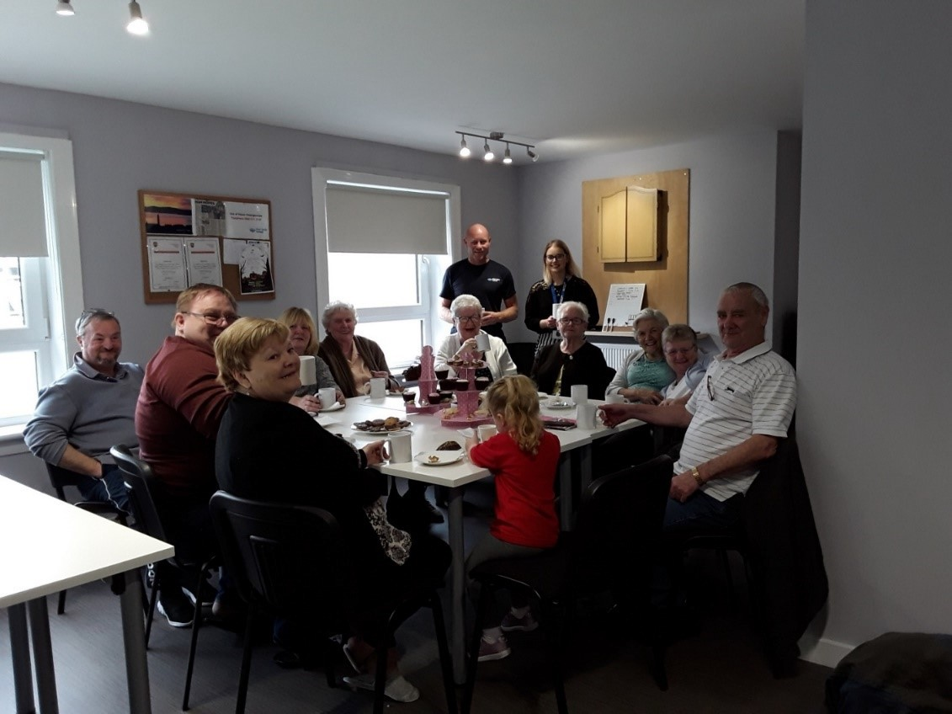

This new Retirement Housing Model had been inspired by the Whitebeck Court development in Manchester, and some tenants and staff mentioned having visited this project.

We went to Manchester and see their set-up and that’s the way it is down there.
In Whitebeck court, they’ve got a shop and a cafe. It’s really, really good. The tenants don’t need to leave the Court at all. There was a hairdressers.
Everything was there (Staff).

In Broomhill Court, the full-time Retirement Housing Coordinator was employed and a community flat, art flat, and guest apartment were all introduced as mechanisms to tackle social isolation and loneliness. Activities helped promote improved health and wellbeing, as well as develop a sense of security and a sense of belonging.
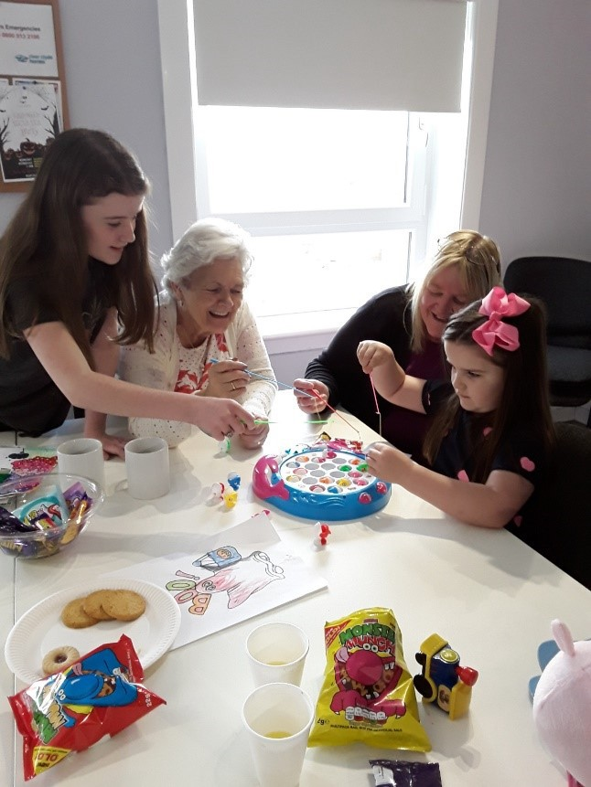
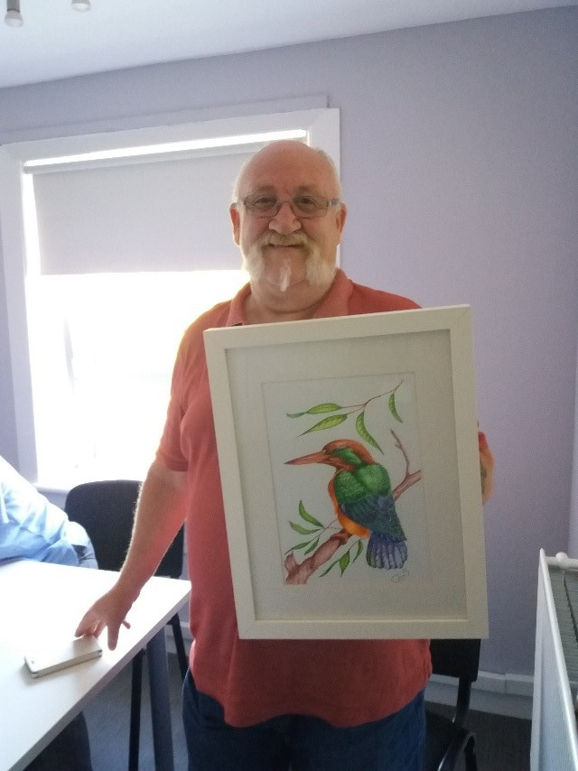
A particular initiative within Broomhill Court was the launch of a community flat, ‘Suite 16’, as a strategy to tackle isolation among some older residents. This community flat for daily use by those living in Broomhill Court opened in April 2018. A range of activities have been facilitated by the Retirement Housing Coordinator, including a Breakfast Club, Lunch Club, Cash Bingo, Games Drop-ins and Fish Teas. RCH staff felt that the aim of reducing social isolation and loneliness has largely been achieved, as evidenced from records and photographs of activities which had taken place.
Residents also articulated the benefits that they were receiving from being more involved in their block and community. They agreed that the Suite 16 project had a positive impact on reducing isolation and loneliness, providing an easily accessible place for tenants to meet and get involved in activities.

By September 2018, only 13 out of 256 flats remained vacant, with Broomhill Court achieving a 91% occupancy rate and Broomhill Occupancy rate overall reaching 94%. Lost rent on empty properties reduced by 86% (£70,051 in November 2016 to £9,622 in August 2018).

Fig 4: Lettings outcomes – Broomhill Court

Broomhill Court Occupancy at Nov 2016 – 35% Broomhill Court Occupancy at Nov 2018 – 100%
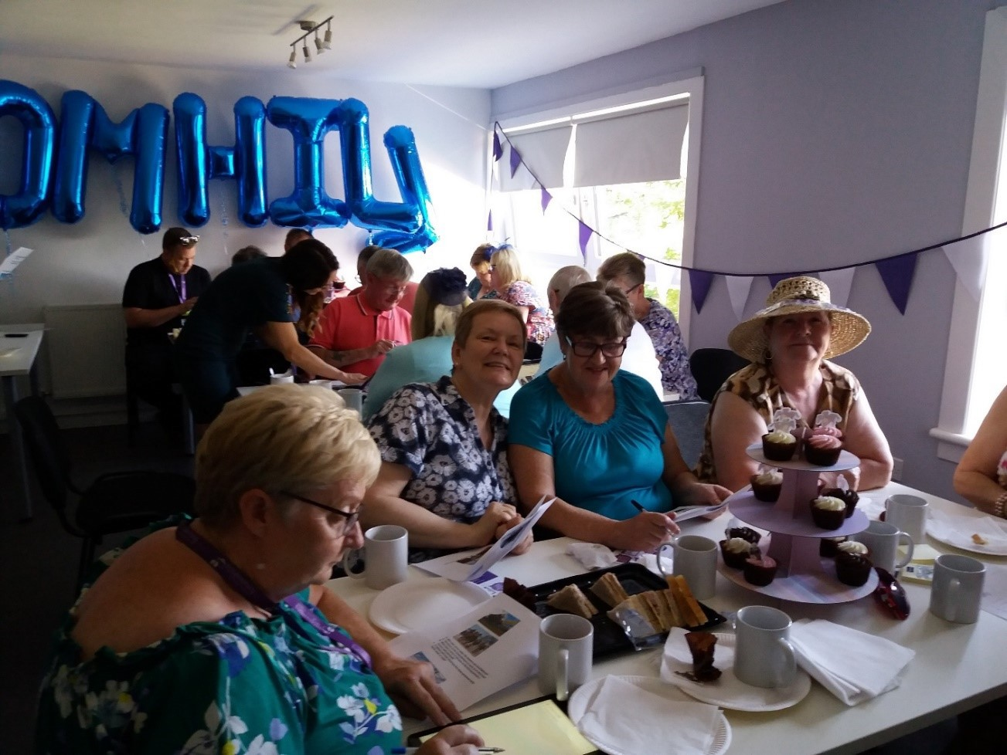

A Silver Living housing status was introduced at Whinhill Court high rise block, adjacent to Broomhill Court. Although this did not have the same fully enhanced retirement model, it still reflected a strategy to encourage older age groups to take advantage of accessible living in the refurbished block. Although the lettings policies for Broomhill and Whinhill Court focused on older age groups, this did not constitute a general policy to encourage older people to the area. Rather the initiatives sought to improve occupancy and sustainability of the high rise blocks while still seeking to encourage a diverse range of tenants to the area. Nonetheless, local data, including the local Housing Need and Demand Assessment had reviewed the need for appropriate retirement housing, finding that there was a demand locally.

Combined with the physical upgrading, lettings practice had resulted in a significant reduction in void properties on the estate. At the time of the evaluation data collection, the Broomhill area was almost fully occupied, a hugely significant turnaround in the liveability of the estate.

And it’s a pleasure to do viewings, aye, It’s job satisfaction. I think because you had a good product to offer so you were able to give good information so you could say don’t worry about that light bulb that’s wonky we’ll get it fixed (Staff).

Sensitive lettings practice was also highlighted as an important contributor to lowering levels of crime, and improvements in tenancy sustainment in Broomhill. Participants acknowledged that this was an important factor in the success of the regeneration

going forwards. Indeed there were some concerns for the sustainability of the community if the approach was not continued.

Some participants suggested that the community could benefit from new build development that would provide some diversity of accommodation and bring younger families into the community.

There isn’t a high number of families in the area. Maybe that’s one of the opportunities, is new build up here to get families (Staff).

If you mix it up within a community and have different types of accommodation, people can stay within their community but change housing as their lifestyle changes, you know when you move from a single person to having a family, to older (Stakeholder).

Broomhill Local Housing Office

The Broomhill Local Office opened in February 2015 as a focal point for residents during the regeneration works and for new customer housing enquiries. This base enabled staff to be more visible in the community and to get to know their customers better. Local staff liaised with customers during demolition works at Drumfrochar Square, discussing their rehousing options. They also engaged with the community in ongoing discussions about the improvement works programme and helped set up show flats as part of marketing the newly refurbished vacant properties.
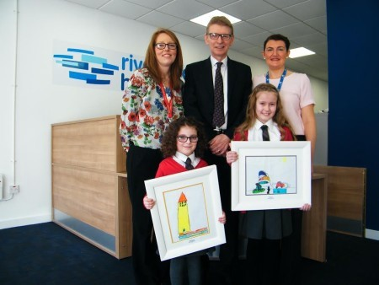

Residents, staff and stakeholders/partners all highlighted the important role of RCH’s Broomhill Office for providing a central location for tenants to seek support and information. The central location on the estate had been crucial to developing links with the community for implementation of regeneration interventions, as well as for promoting community cohesion and wellbeing.

Marketing

Tenants, residents and staff all commented that River Clyde Homes had developed a strong marketing and communication strategy that utilised social media, a web page

and local newspapers to communicate the changes across Broomhill. Traditionally the local newspaper had published stories presenting a poor image of the neighbourhood, so challenging this perception through a positive publicity campaign building a picture of Broomhill as an improving community was vital to changing perceptions. River Clyde Homes also organised ‘doors open days’ and converted a flat into a gallery displaying photography. Such activities were instrumental in bringing people in to the area to challenge and change negative perceptions.

When you think about it, that’s a couple of hundred people turning up in Broomhill, going through what were pretty shabby front doors and foyers and in the lift and up to the 11th floor to see a flat, but actually, amazing views, great exhibition… In terms of not only outside but inside perceptions I think it helped people to see the community in a different way (Staff).

The lettings team introduced show flats at Broomhill Way and in the three high rise blocks, promoting the refurbished properties using visual boards in the foyers of the high rise buildings. Investment in attracting new tenants also included provision of carpets and decoration. The profile of the estate was raised through open days, outreach, the ‘Doors Open Day’ and Scottish Housing Day. Attractive leaflets, fliers and posters were produced for Broomhill Court retirement housing supplemented by promotion in the local press and through ‘Rightmove’. Where feasible, furniture from flats was recycled for other customers. Close performance monitoring and regular staff meetings ensured effective delivery of the marketing and lettings strategies.

Community Development Initiatives

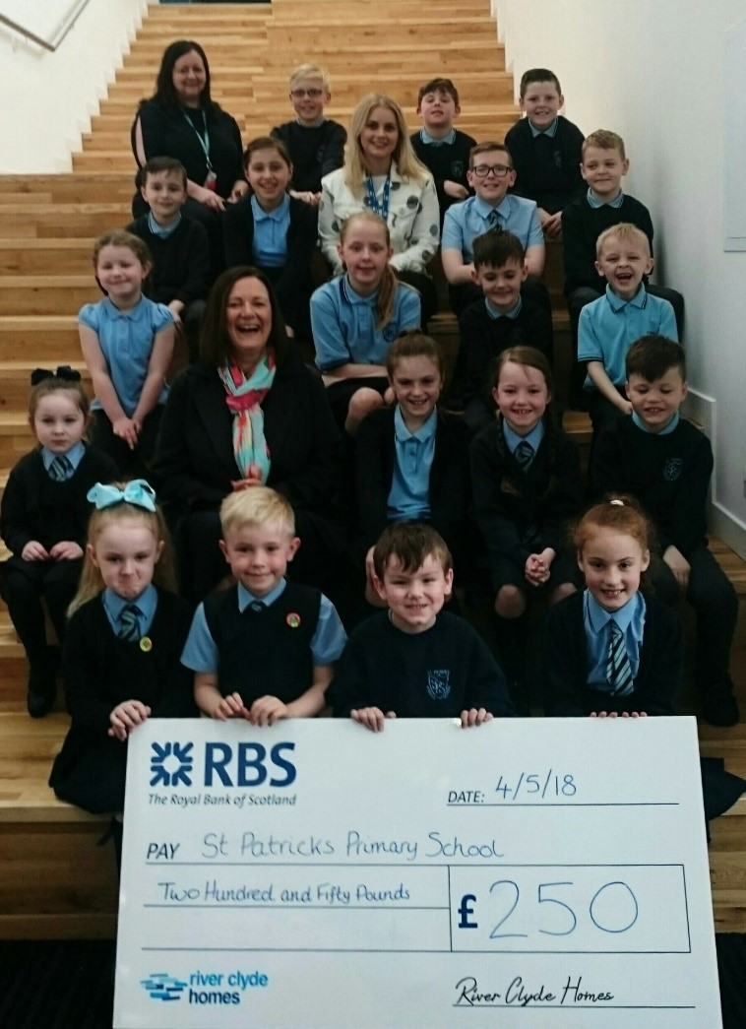
Community Development Officer

As part of the GIRFB commitment to delivering community investment alongside the Broomhill housing regeneration, a Community Development Officer (CDO) post was created with the aim of supporting community sustainability. The post was jointly funded by River Clyde Homes, Riverside Inverclyde and the local Health and Social Care Partnership (HSCP), from February 2017- March 2019.

Working from the Broomhill local office, the post effectively bridged the housing and community aspects of the regeneration programme. For example, the Community Development Officer has worked behind the scenes to apply for grants in order to progress projects in the Suite 16 facility in Broomhill Court (for example, a Pop-Up Library delivered jointly with Inverclyde Council).

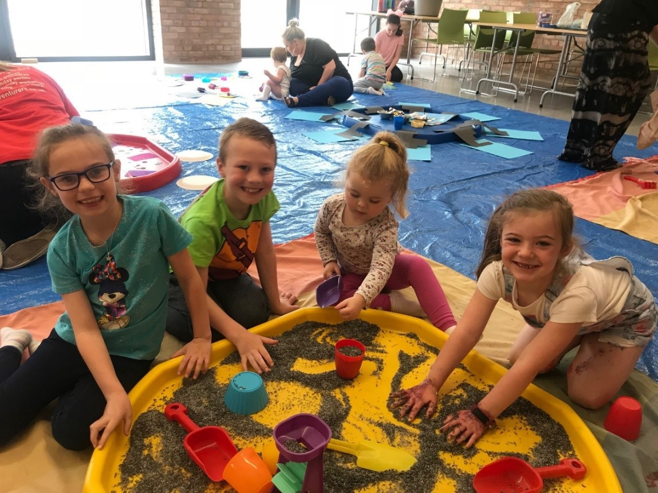

Other examples of community activities, led by the CDO, included:
- Big Bike Revival. This project (which saw £1000 from Cycle UK’s Big Bike Revival Fund) was undertaken by River Clyde Homes to encourage people from Broomhill to start cycling to improve physical and mental wellbeing. In May 2017, local company Clyde Activity Bikes, led group rides and facilitated Dr Bike maintenance workshops. The project was later expanded to include all customers across Inverclyde.
- Broomhill Jobs Fair to encourage local people into employment and training opportunities. This project was in conjunction with local partners including the Trust, DWP, Skills Development Scotland, Street League, Inverclyde Council, Greenock Morton Football Club and many more.
- Family Halloween Party (2017) to encourage children off the streets on Halloween and to promote local families use of the Community Hub
- Christmas Lunch and Crafts. A Christmas (2017) lunch for Broomhill residents facilitated socialising with neighbours. The event sought to bring longstanding and new customers together to help build community integration and to encourage the use of the recently opened Broomhill Community Hub (below). A free after school Christmas crafts session was also hosted for local children in the Community Hub with the aim of encouraging young members of the community to use the facilities, as well as providing an opportunity to make gifts.
- Children’s Clothing Drive and Sale. Also held in the Broomhill Community Hub, this event aimed to reduce waste, tackle child poverty and raise money to invest back into the community via local primary schools. The sale raised £215, which RCH made up to £500 donated to local primary schools to subsidise school trips for struggling families.
- Build-a-bear workshop for local nursery pupils funded by Graham Roofing as part of their community benefits

- RCH secured £503 from Radio Clyde’s Cash for Kids to facilitate two free messy play sessions with ARTventurers for children of Broomhill residents (2018).
- Christmas dinner (2018) funded by Inverclyde Council’s Provost Common Good Fund
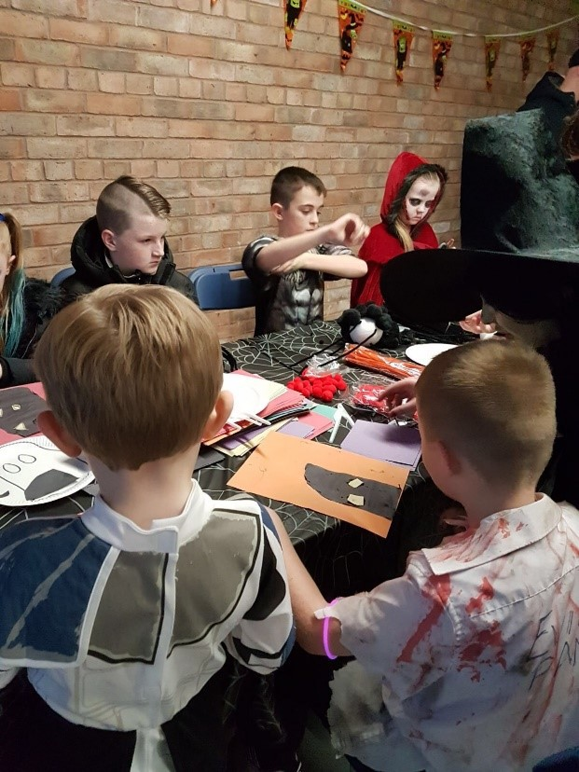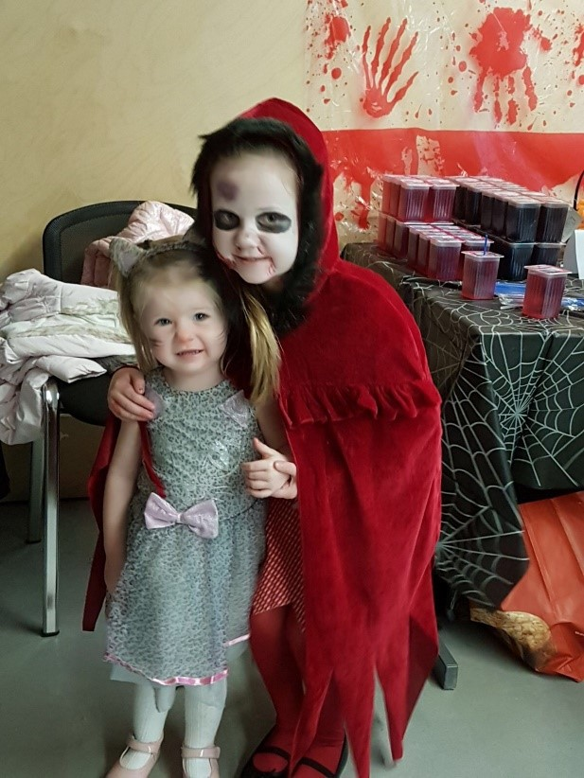

Evaluation data indicated that the community regeneration strategy had been successful in delivering social impact for local residents. In some discussion groups, there was also a wider sense that River Clyde Homes and its staff had ‘gone the extra mile’ in community investment (as indicated in the examples above).
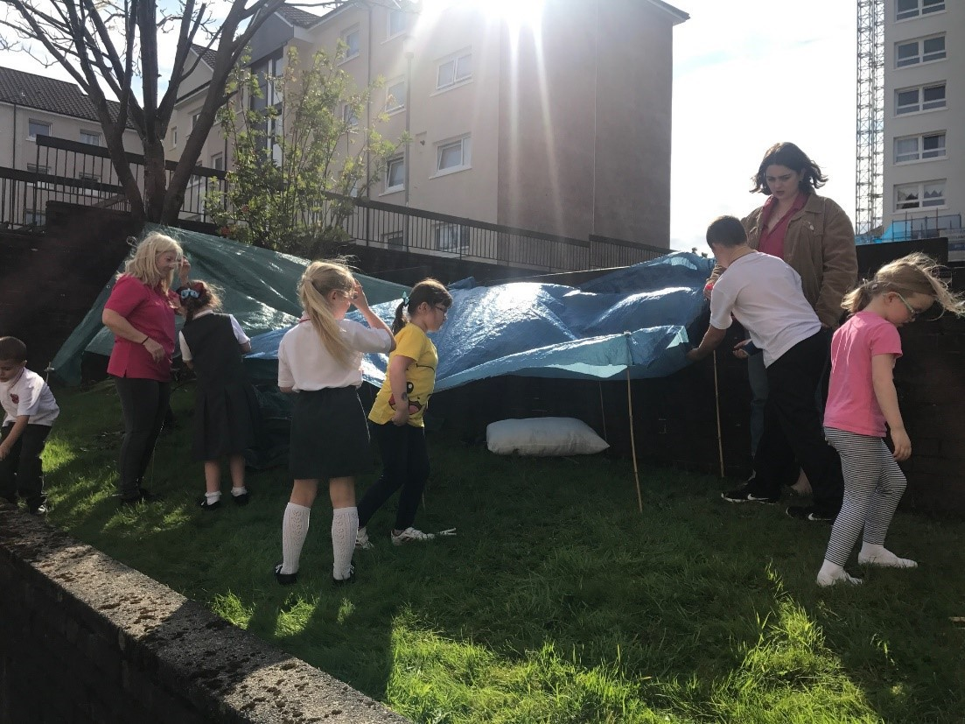

Partners and stakeholders confirmed that the community development officer contributed greatly to the development of a sense of community with a variety of activities creating opportunities for local people to meet and feel involved. These projects brought people in to Broomhill, which changed the perception of the area. Several projects linked in with the local schools which gave young people the opportunity to contribute to their local community. However, some people reported that community engagement in some of these activities was limited with young families less willing to get involved.

We were wondering why are we not getting a lot of teenagers at things with the project. When we’re speaking to folk, there isn’t a lot of teenagers in the area anymore (Stakeholder).
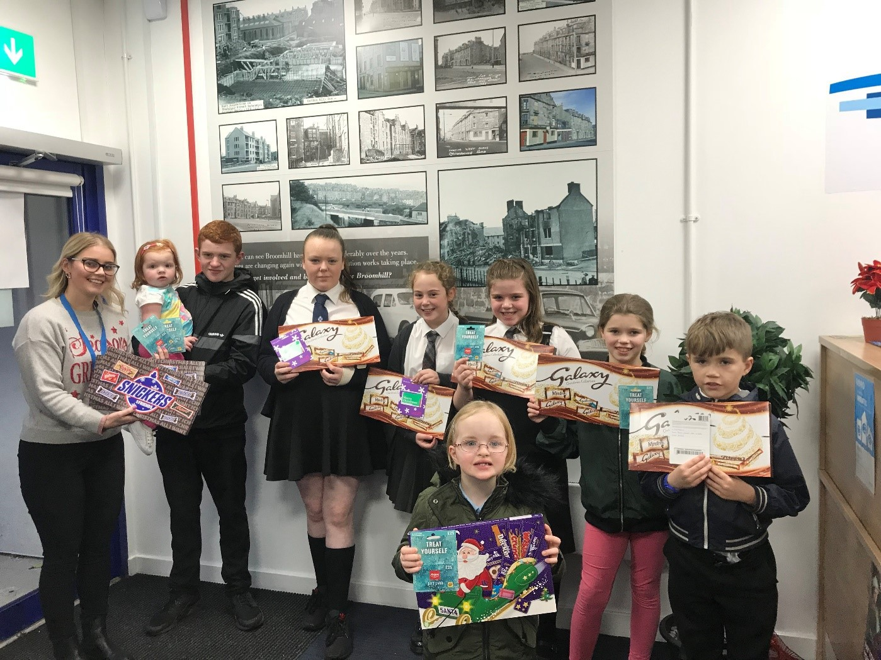

Skills development

In addition to employment initiatives in the main housing refurbishment programme, two key employability initiatives were identified by Broomhill regeneration partners.
- To encourage local employment, River Clyde Homes organised Broomhill Jobs Fair in 2017 as part of the social regeneration of the estate. The jobs fair was designed to help residents get back to work and/or training, and was delivered in partnership with West College Scotland, Greenock Morton Football Club Trust, Inverclyde Council and other partners. More than 30 people registered their interest in looking for training or employment opportunities and many more came along to take part in the family activities, which included face painting and cupcake decorating.

- Greenock Morton Positive Goals1 aimed to further support employability within Broomhill. RCH partnered with Greenock Morton Community Trust to deliver two rounds of their Positive Goals Employability Programme for customers in 2017, and committed funds for another three rounds in 2018. Positive Goals was designed to support job seekers on their journey back to work. During each six-week long project, a labour market related employability programme was delivered including three aspects of qualifications: World Host Principles of Customer Service; Core Skills in IT at Level 2, 3 or 4; and Emergency First Aid. Participants were supported for 13 weeks after Positive Goals ended to maximise their chances of securing employment. RCH information indicated that the first two rounds saw 18 participants completing the programme and 61% of these progressed to employment or further education.
The Community Development Officer contributed to the development of employment and training opportunities through these initiatives (jobs fairs, apprenticeship schemes, and Greenock Morton Positive Goals). However, it was recognised that these successes were not enough to offset the high levels of deprivation on the estate and even wider engagement with the community and stakeholders needed to continue.
Participants commented on the strong sense of community on the Broomhill estate, while acknowledging that it remained a deprived area

It is a depressed area and I think unemployment has done a great deal. If young people had jobs and that, it wouldn’t be just as bad as it is (Stakeholder).
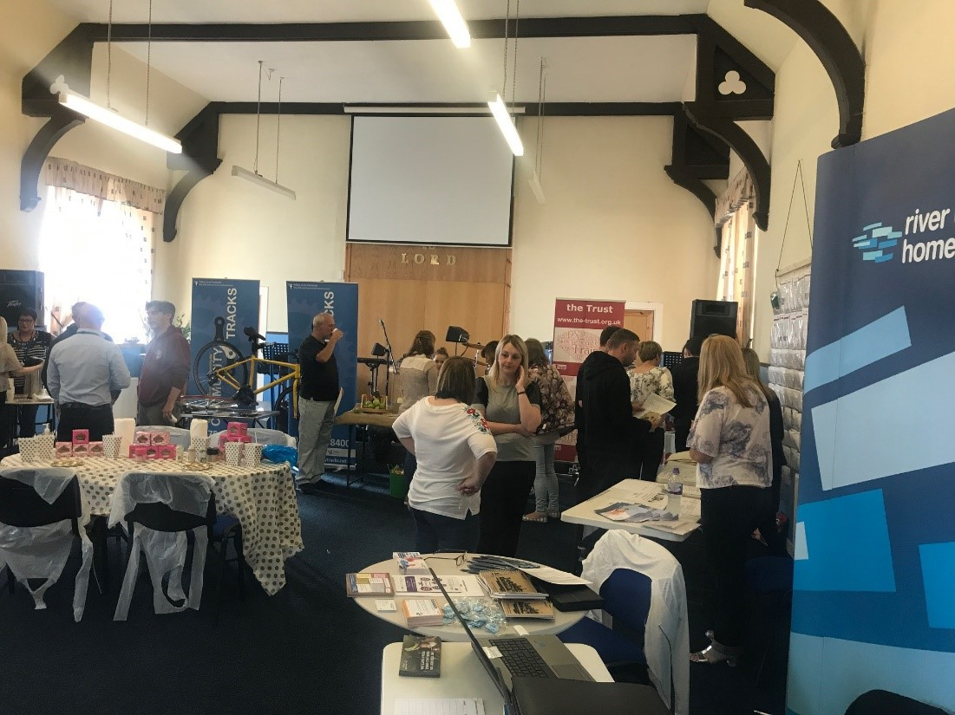

¹ Positive Goals is a partnership with Greenock Morton FC’s community Trust to develop employability initiatives.

Partnership Organisation Projects

RIG Arts – Art Flat and Broomhill Art Project.

In 2015, RCH commissioned local arts charity, RIG Arts, to work with local people by providing free art classes in the Broomhill Art Flat, located in Broomhill Court high rise block. This project sought to build community spirit, give residents a voice in the regeneration process, and celebrate the area’s rich heritage.
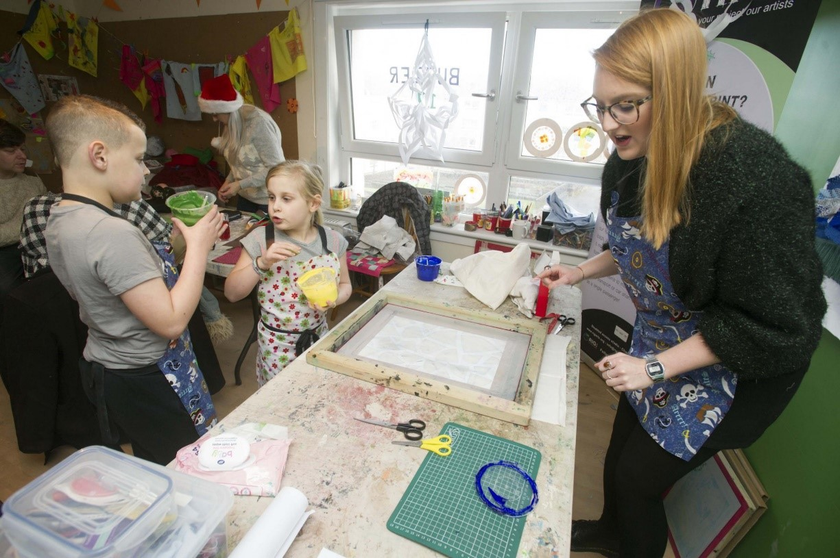
The Art flat was established as a three-year project, but continued into a fourth year, with funding provided by RCH. The free community art classes included a wide range of creative arts activities: furniture upcycling, stained glass, stone carving, textile upcycling, song writing, photography, filming, mosaics and ceramics. The project held specialist classes for children and for older people. RIG Arts also led on a local community mural, a heritage trail and community garden.

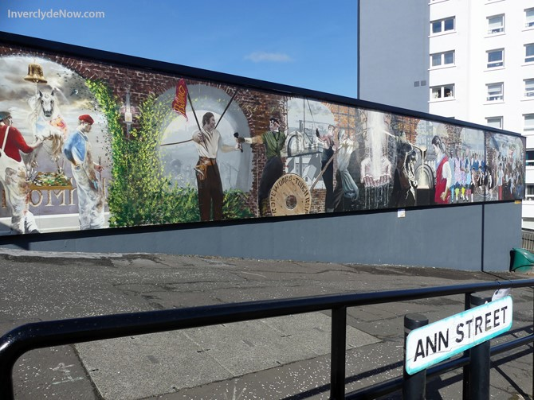
Monitoring information indicated that the project had engaged 3518 participants in 579 arts workshops since September 2015. Most participants were from Broomhill, but, notably, people came from other parts of Inverclyde to join the workshops.
RIG Arts secured £431,078 in funding for the area, to facilitate classes and establish the community garden. The Art Project has been a significant innovation in the regeneration programme, winning a Scottish Urban

Regeneration Forum (SURF) Regeneration Award in 2017 in recognition of best practice and innovation in community regeneration. Across discussion groups, the role of RIG Arts in bringing creativity to the area and the regeneration programme was recognised.

I think, certainly [Rig Arts] has assisted with that and Suite 16. Evaluations show that residents say that having that facility had changed their lives (Staff).

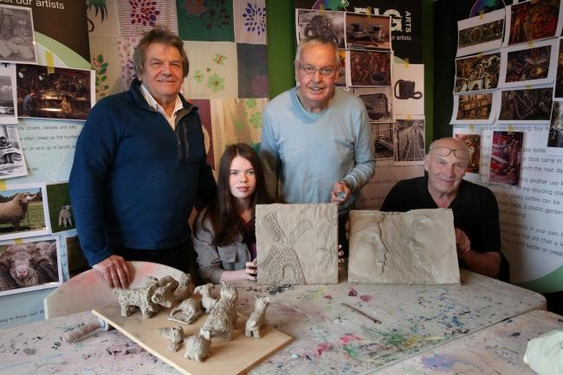

The Broomhill Art project appeared unique in its use of art as a tool for regeneration, consultation and strengthening community bonds. In discussion groups, RIG Arts was credited for building community spirit and providing residents with a voice in the regeneration process. Residents who attended arts classes and activities developed skills in the creative sector and built relationships with neighbours. The RIG Arts project was also key to Broomhill developing a sense of place and bringing people to the community. Participants commented that the Arts flat had not only enabled people to develop skills and confidence but had brought people in to Broomhill and changed the perceptions of the area.

They’ve not only brought art and creativity to the area but they’ve actually brought people living like, for instance, in Kilmalcolm,2 into Broomhill. So the art classes aren’t just for the Broomhill community they’re actually for the wider community too. It’s changed the perception of Broomhill (Staff).

Broomhill Gardens and Community Hub

The Broomhill Gardens and Community Hub opened in October 2017 as a result of a partnership between Inverclyde Council and Inverclyde Association for Mental Health (IAMH). The Hub houses the headquarters of IAMH and their subsidiary social
enterprise company ‘In-Work’. There is also a café and community hall. Broomhill TARA was also involved in the development of the project as they wished to see provision of a local community centre, but did not themselves wish to have

responsibility for management of a building. As IAMH were looking for a new headquarters, the merger of both ideas flourished under the same roof.
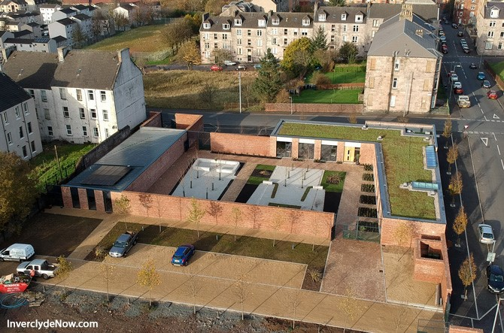

The Community Hub, although not planned as part of the regeneration, was reported to have played a significant role in bringing people into Broomhill, and in providing employment/skills for local people. The community hub and RIG Arts project were cited as having supported residents to develop skills which could be transferable to work or other environments.

Infrastructure works (Public realm)

Riverside Inverclyde (ri) were undertaking road realignment works at nearby Bakers Brae during the evaluation period. The works aimed to soften the bend on this steep hill, so improving access and contributing further to regeneration of the wider neighbourhood. The work sought to complement River Clyde Homes’ investment in Broomhill and landscape architects from both organisations were working together to ensure that designs matched and created a boulevard approach on Drumfrochar road.

Outcomes and Discussion

The findings from the evaluation indicate a reasonably close fit with the outcomes of the 2016 Place Standard exercise (Inverclyde Community Safety Partnership, 2016). Local residents assessed 14 indicators on a scale of 1-7, with 7 being the highest.
While no indicators were assessed at the maximum of 7, housing in Broomhill achieved a score of, 6, indicating the early positive impact of the regeneration improvement works. Identity and influence (sense of community and involvement) also rated highly, with provision of natural space and play space achieving poorer scores as also indicated in the discussion groups. The variation across the themes was

supported by the evaluation findings in that those achieving a rating of six were also reported as positive achievements in the evaluation. The Place Standard exercise was also based on a small, qualitative sample, but is a useful comparison with the evaluation data discussed in this section.

Figure 5: Inverclyde Place Standard Outcomes
Place Standard Indicator | Place standard rating  (7 is highest )
 | 7
Housing  Identity and belonging Influence and sense of control. | 6
Public transport Feeling safe | 5
Impact of vehicles | 4
Moving around Social interaction  Work and the Economy (wider Inverclyde area) | 3
Streets and spaces Care and maintenance | 2
Facilities and amenities Natural space  Play and recreation | 1
Source: 2016 Place Standard exercise (Inverclyde Community Safety Partnership, 2016).

Local identity and belonging

Evaluation participants identified a growing sense of pride in the Broomhill neighbourhood and a feeling that local life was improving. One long-term resident summarised changing perceptions as:
and of course, people used to say `are you moving to Broomhill?’ But now it’s… they say to me there’s people trying to get into here now (Resident).

Although there was also recognition that it would take time for the reputation of the estate to improve in the wider area, participants acknowledged that the regeneration interventions had returned a sense of community to the neighbourhood. As the area had improved, so too had tenants’ pride in place. There were some difference of opinion, with some participants describing how ‘territoriality’ could still be a feature of some areas of the local authority, including Broomhill. Some participants felt that Broomhill was resilient and open while others suggested that some residents still tended not to interact much with people from different areas. In spite of this, interviewees felt that residents tended to look after one another and most felt part of a wider community.

Wellbeing and Feelings of Safety

The evaluation evidence indicated strongly that the combination of housing improvements and community development activities contributed to an improved sense of well-being for Broomhill residents. Previously the estate had a bad reputation, but people who took part in the discussions said that they now generally felt safe in the Broomhill area. Participants reported that levels of crime had dropped and there was a sense that people felt much safer than prior to the regeneration interventions.
However, they acknowledged there were still some problems with crime, particularly relating to drug use, although these issues were considered to be being managed well by local service providers. Importantly, the perception of crime had reduced which had contributed to changing both insider and outsider expectations of the area.

Antisocial behaviour and gang culture had also reduced. This was attributed partly to the new larger school campuses which had integrated young people from different communities. Tenants and residents reported that crime prevention measures in Broomhill, such as CCTV, better lighting and secure doorways had helped to reduce crime. These measures had been developed in partnership with Police Scotland and Inverclyde Council. As noted above, stakeholders highlighted that the RCH Broomhill Office had facilitated strong partnership working, enabling information sharing and developing a stronger knowledge of the local community.

People act anti-socially if they think no-one cares. For the first time in maybe 20-odd years there are people caring about this area and it’s made a difference and a lot of that is the area itself – we’re not going to tolerate ASB, they report stuff, they’ll contact the office or they’ll contact the police (Stakeholder).

The community police officers drop in, probably, weekly to let us know what’s happening in the area and vice versa, we make them aware if there are any issues or hot spots (Staff).

Satisfaction with local facilities

In the interviews and discussions, it was reported that local services like health, education and amenities were of good quality, and located close by. The residents of Broomhill Court highlighted the importance of the Suite 16 project in providing a facility for social activities. Similarly, the Community Hub provided a community-wide venue for events and activities. However, across the groups, there was a consensus that facilities for children and young people were less satisfactory. The neighbourhood lacked public green space for use by residents and there were no children’s play areas suitable for either formal or informal play.

We’ve still not really got anything for children. No play areas. I know they were talking about it at some point and it’s maybe still in the background but there’s not really anywhere for kids to play (Resident).

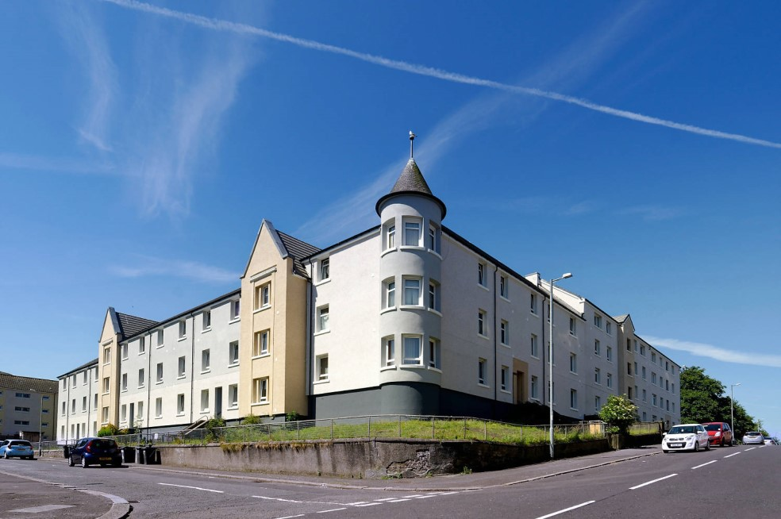

However, some residents expressed fear that external facilities such as benches or parks could attract antisocial behaviour to the area, suggesting that some residents were still fearful that crime and antisocial behaviour could return to area. Stakeholders were concerned that such views might affect the external improvements required to improve external spaces for the high rise blocks

Although, when they did the place standard, it was shown that a lot of residents would like a park. But there’s fear thing about antisocial behaviour and honestly we had a battle to get two benches made by the community put into the community garden (Stakeholder).
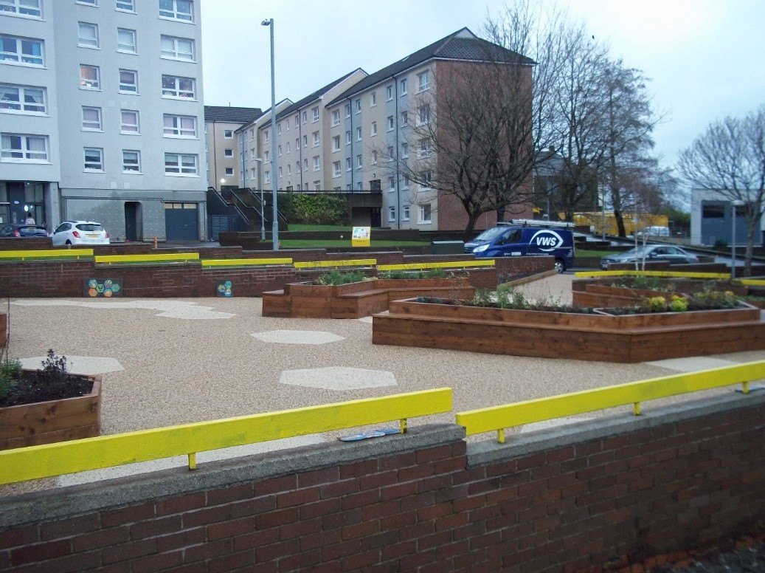

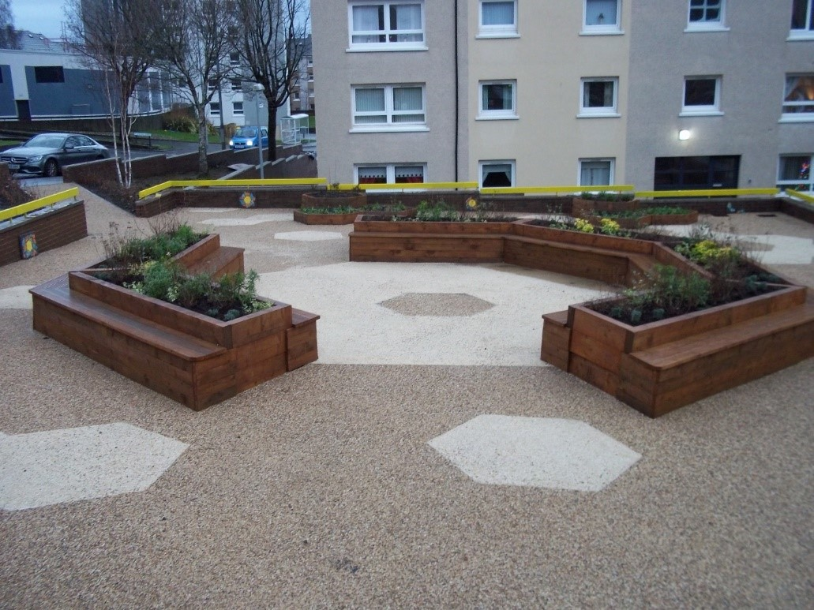

Resident Voice and influence

People living on the Broomhill estate knew more about the regeneration project than people living in the wider area as they were more likely to have been to meetings or events about the regeneration plans than were people living elsewhere. Residents felt that there had been sufficient opportunities to make a contribution to the regeneration project though meetings, consultations and surveys. However, residents and staff recognised that engagement with owners of sold properties had been less effective and liaison could be improved for future regeneration schemes. Early in the regeneration process, River Clyde Homes responded to the feedback from their consultation with the community resulting in the prevention of the demolition of Broomhill Court. Although participation events were open to anyone, staff did report that many of the same people tended to be most regularly involved in events. This could be a particular concern if there was an issue where residents were less happy, but perhaps had not been involved in earlier open discussions and decision-making.

The Community didn’t want the place to be raised to the ground and started again…The people who worked through the TARA, that’s what they wanted and fought for. I would say that that’s something that we’ve delivered (Staff).

At one point, RCH actually considered knocking the whole area down and rebuilding but it was the support from the community made them decide to regenerate the area (Stakeholder).

The Tenants and Residents Association (Broomhill TARA) was heavily involved in consultation activities. In terms of the wider community, there had been consultations around various interventions such as the environmental landscaping. In some instances, the response from the wider community was disappointing and participants commented that there was a lack of engagement from the younger generation in Broomhill.

I think another thing that’s lacking in this area is the involvement of youth. I don’t think it’s recognised. I’m just going by my personal experience (Stakeholder).

Learning from Broomhill regeneration

RCH internal reviews identified a number of learning points from the Broomhill regeneration experience. Having a co-ordinated project plan was fundamental to the process and delivery needed to be supported by regular communication, such as weekly meetings to highlight issues arising and find solutions or compromise.
Communication with customers, including owners, was key, for example, when the programmes slips. Consistency of staff and a joined up approach throughout the process would enhance delivery.
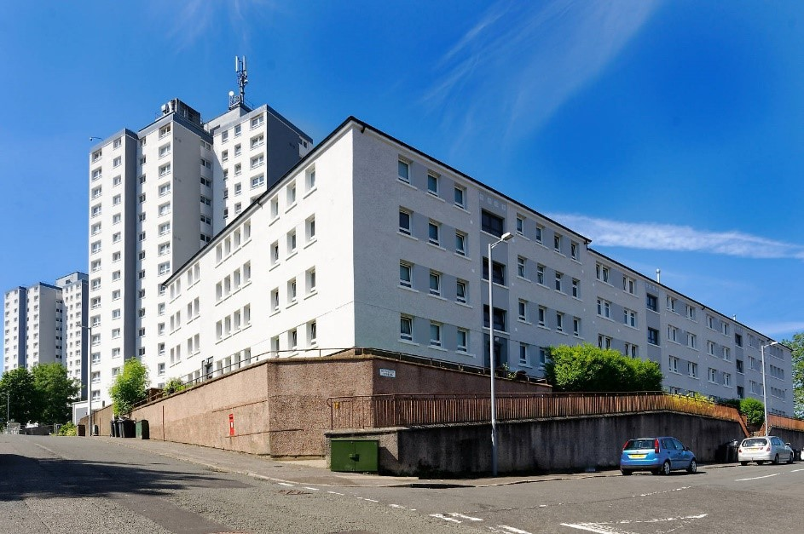
Subsequent projects could run more smoothly by agreeing a clear process in advance for completion of snagging on properties. The Biomass heating installed was quite different from the previous heating system, so customers needed to be informed about its operation. There was agreement that the decoration pack did not work for everyone.

It was recognised that the local office was key to staff being visible and accessible in the area. Staff built up knowledge about customers with complex lifestyles and worked with them to sustain their tenancies. Partnership working with Community Police, HSCP, Education, ri, DWP and the Trust was a crucial element. Having a dedicated Housing Officer focusing on marketing/letting was vital, supported by newsletters.
The handyperson was vital throughout.

Potentially transferable tools included having a base in the community, working together as a team and putting customers at the heart of the project. Developing clear communication through a range of channels was vital – for example telling people what is happening through signs and billboards. Sharing knowledge and information within the organisation, including measuring performance and celebrating success.

Staff felt empowered. Aye, housing management was great. She let’s us kind of do our own thing but she’s got confidence in, and trusts us, to make our own decisions and stuff like that. It wasn’t as if you were kind of wary about doing something (Staff).

Looking ahead, some participants were concerned that there would not be the continued financial investment required to ensure the sustainability of the completed

regeneration. Participants felt strongly that continued investment was required to ensure that the environmental landscaping was well maintained. Importantly, residents and staff felt that both the RCH Broomhill Office and the Community Development Officer post were essential to the sustainability of the neighbourhood, and withdrawing these services too soon would risk subsequent decline or failure. Staff were concerned that a shift of focus to other areas could also pose a threat to the sustainability of the Broomhill regeneration project. They highlighted that the success of the project had raised expectations more widely and that River Clyde Homes may be unable to recreate the successes of Broomhill in other parts of Inverclyde because a similar level of financial investment may not be available in future.

“I think we’ve set the bar too high for other areas. There are people wanting to move to Broomhill because of the product offer. The bar has been set and we’ll never be able to do something as good as this.” (Staff)

Conclusion and Recommendations

This section presents the evaluation conclusions and recommendations with reference to the core aims of the study set out above:

  - examine how effectively the agreed regeneration aims, impacts and outcomes had been addressed
  - provide an initial assessment of the overall impact of Broomhill Regeneration
  - make recommendations for longer term monitoring of sustainability, and for transferring learning to other projects.

Effectiveness in addressing regeneration aims, impacts and outcomes

Returning to the wider aims of the Getting It Right For Broomhill Governance Group, Figure 6 shows how regeneration and linked interventions to date have helped move towards meeting the key goals for Broomhill residents, participating organisations, and the wider community.

Figure 6: Progress on regeneration aims and anticipated outcomes

Aims | Progress and Evidence
Work even more closely with communities and residents to further involve the public in the design and delivery of the services they use (co- production) | Mostly achieved  Robust evidence of consultation throughout the regeneration, including for the masterplan. GIRFB governance group worked closely with the Broomhill Community to develop a set of commonly agreed outcomes. Broomhill TARA was heavily involved in the regeneration process, helping to include local tenants and residents.
Identify and harness all the assets available in a community to help deliver positive outcomes | In Progress  Multi-partner input and co-ordinating activities such as the Community Development Officer post were instrumental in building a comprehensive approach, embracing housing improvements, community support, the arts, and economic initiatives, to improve quality of life in Broomhill.

Support families/households to help themselves and reduce dependency | In Progress  A range of employment and social/creative initiatives were delivered which developed skills and confidence.  Notable successes were the RIG Arts project and the Suite 16 initiative to tackle isolation. The Community Development Officer post also contributed by supporting these initiatives.
Support more families/individuals into employment and into good quality, sustained work | In Progress  Apprenticeships were a feature of the core housing refurbishment contract. Jobs fairs and Greenock Morton Positive Goals also  achieved some successes. Broomhill Garden and Community Hub created some local employment opportunities.
Improve levels of physical and mental health | In Progress  Health benefits of improved quality of housing and services.  -493 homes in Broomhill meet SQSH standards  -516 homes in Broomhill meet EESSH standards Suite 16 initiative has reduced social isolation for Broomhill Court households and the Arts flat tackled social issues on the estate.
Reduce drug and alcohol misuse | In Progress made  Contribution of sensitive lettings practice. Staff and residents report fewer incidences of drug taking and fewer related neighbourhood issues.
Reduce levels of reoffending and antisocial behaviour | Mostly achieved  A high proportion of participants reported that antisocial behaviour incidents had reduced. Levels of reporting indicated tenants were taking more pride in the area.  Perceptions of crime and antisocial behaviour in the area have reduced and tenants and residents report feeling safer within Broomhill.  Sensitive lettings practice, combined with CCTV and housing management practice all contributed to reducing antisocial behaviour.
Support families with children to achieve more | In Progress  Children’s clothing drive and sale aimed to reduce waste and tackle poverty. Some fund raising to invest back into the local community.  Cash for Kids summer grant provided free play sessions, though engagement was lower than hoped.

Build on our existing partnership working to enhance integrated services and improved outcomes | Mostly achieved  GIRFB governance group led to parties working together for mutually beneficial outcomes, however engagement from some partners lessened as the regeneration project neared completion.  Broomhill Jobs fair was delivered by River Clyde Homes in partnership with West College Scotland, Morton, Inverclyde Council and partners.  River Clyde Homes teamed up with Greenock Morton Community Trust to deliver two rounds of their Positive Goals Employability Programme for customers.  Successful partnership approach with local police to target and reduce antisocial behaviour locally
Look for opportunities to reduce duplication, better use resources and share services (public, third and private sectors) | In Progress  Evidence of effective partnership working, but scope remains for further clarification of agency roles and remit to enhance collaboration.
Anticipated outcomes/impacts for organisations | Progress and Evidence
Reducing demand and focussing on early intervention | In Progress  Evaluation has focused on implementation of regeneration, but there is evidence of improved housing practice and partnership working.
Removing duplication and waste by considering delivery from a whole system perspective | In Progress  GIRFB sought to take a comprehensive partnership approach with shared aims and intended outcomes.
Involving individuals/families and practitioners directly in recognising need for and developing service re-design | Mostly achieved  Consultation exercises were carried out periodically throughout the regeneration programme, including for the masterplan.  GIRFB governance group worked closely with the Broomhill Community to develop a set of commonly agreed outcomes. Broomhill TARA was closely involved in the regeneration process, including local tenants and residents.
Intended community outcomes | Progress and Evidence
Empowered and sustainable community | Mostly achieved  Robust evidence of effective consultation and involvement activities.
Increased wellbeing and reduced inequalities | Progress made  Wellbeing enhanced through housing improvements and community activities. Community initiatives contributed to building

 | confidence and skills to enhance employability and so tackle economic inequality.
Increased feelings of safety | Mostly achieved  Significant reduction in antisocial behaviour incidents and reduced perceptions of crime and anti-social behaviour in the area.  Tenants and residents reported feeling safer within Broomhill, post-regeneration. Supported by introduction of CCTV through partnership working with Police Scotland.
Increased financial security through employment or better access to support and advice services | Progress made  Creative skills development and employment initiatives were delivered. These could be further developed to upscale benefits.
Greater social inclusion of families | Progress made  Community development officer worked with the local community with some success. Potential to scale up to achieve estate greater impact.
All children have the best start and improved opportunities in life | Progress made  Addressed by:  - Improvements to the physical properties through SHQS and EESSH standards  - Community initiatives to reduce waste, tackle poverty and raise money to reinvest in the local community

Assessment of the overall impact of Broomhill Regeneration

In many ways, the success of the Broomhill regeneration programme has been transformative for the community. In less than five years, the neighbourhood has turned around from low demand to high occupancy, through comprehensive housing improvements and parallel community initiatives.

Overall, residents felt that Broomhill had become a much nicer place to live and they felt significantly safer moving around the estate at all times of the day. Tenants were broadly happy with the improvements made to their housing and this general success of the regeneration project was reflected in the rising satisfaction rates recorded by River Clyde Homes’ own tenant surveys. Housing was also already scoring well in the 2016 Inverclyde Community Safety Partnership Place Standard exercise (above), achieving a score of six (where the maximum is seven).

A key factor in the success of Broomhill Regeneration was the extensive programme of community development activities which were developed in parallel with the housing upgrading. A very wide range of activities were undertaken to address social isolation and economic disadvantage and to engage with all groups in the community.

This combination of housing and community interventions, delivered in partnership with residents and key local agencies enabled the transformation of Broomhill

neighbourhood through community regeneration. A key challenge for the future is to sustain the enormous progress which has been achieved in just four years.
