DataSTORRE Deposit Guide

Introduction

DataStorre is an online digital repository of multi-disciplinary research datasets produced at the University of Stirling.
University of Stirling researchers who have produced research data associated with an existing or forthcoming publication, or which has potential use for other researchers, are invited to upload their dataset for sharing and safekeeping. A persistent identifier and suggested citation will be provided.

Accessing DataSTORRE

DataSTORRE can be accessed by visiting the below url or by clicking on the portal link.

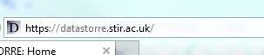

Click on the Stirling Researchers link to login via the University Portal using single sign-on.

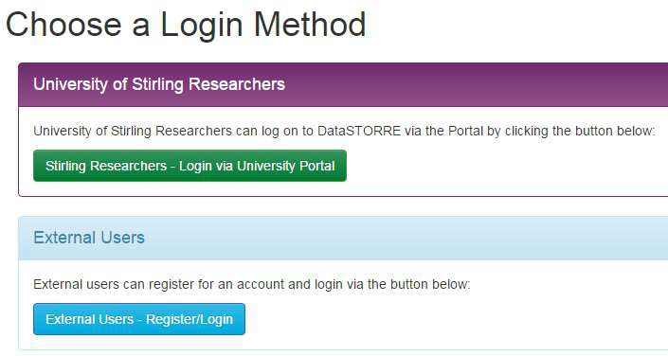

Or in the top left hand corner

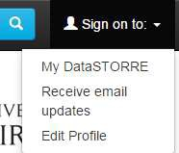

Starting a New Submission

Once you have logged on to the system you will be given the option to start a new submission or view an accepted submission that has been processed in DataSTORRE.
To start a new submission click on the green: Start a New Submission button.

You are given the option to choose a collection in which to deposit your research data. At this time there is only one collection established. Click on the drop down arrow and select University of Stirling> University of Stirling Research Data.

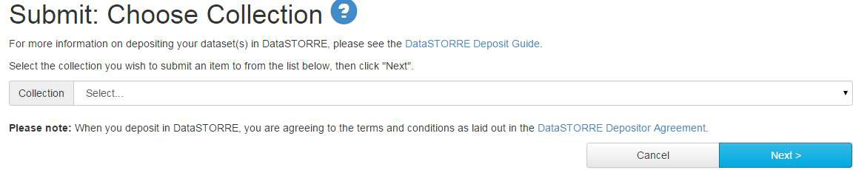

Completing the submission form

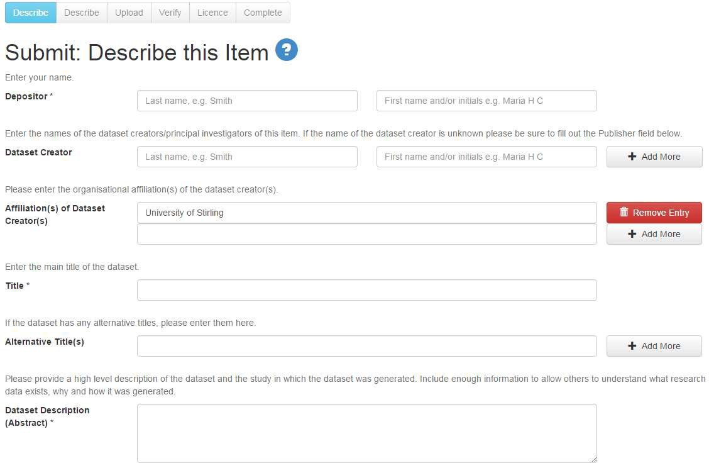

Complete the details on the submission form. Datasets can be deposited by any member of the research team or a research administrator.
Dataset Creator – add all the names of the research team involved in creating that particular dataset. Use the + Add More button to make more input fields appear.
Please note those fields with an asterisk beside them * are mandatory fields and you will not be able to move on to the next page of the submission form until these fields are completed. Please fill in as much information in the submission form as possible to ensure that the dataset is accompanied by a rich and full set of metadata.

If applicable, please enter the date when this dataset was collected or created_ You can enter only a year. a month and a year or a full date.
Please enter as full a date as possible (some funders require you to make the metadata record describing the dataset public within 12 months of the end of collecting the data)

Date Dataset Created /Co llec t ed

Month: (No Month) Day_ Year:

Enter the name of the organisation or service responsible for making the dataset available. Example: University of Stirling. School of Natural sciences. Note. Publisher is a
mandatory field It no creator is specified Dataset Publisher

select each agency that funded the creation of the dataset (if applicable). If this dataset has any additional funders that do not appear in this list, please enter them below.
Funder{s) N/A

AHRC - Arts and Humanities Research Council
BBSRC - Biotechnology and Biological Sciences Research Council CRUK - Cancer Research UK
EC - European Commission
EPSRC - Engineering and Physical Sciences Research Council

Please enter the name(s) of any additional funder(s} that do not appear on the above list

Other Funder(s)

+ Add More

Please enter the Contract or Grant Number of the Project that this dataset relates to. This information is available In RMS (select the required Contract In RMS. then "Financials", and the Contract Number Is held in the "External Reference - Contract Number" field).
Contract/Grant Number + Add More

Please enter the Title of the Project that this dataset relates to. This information is available in RMS (Select the required Contract in RMS and the Title is the first field on the "Key information" lab).
Contract' Grant Title + Add More

select the type(s} of content of the item. To select more than one value In the list. hold down the "CTRL" or "Shift'' key If you require any additional types added to the list please
contact the Research Data Management Team (researchdatamanagement@stlr ac.uk)
Type. Artifact
Collection Dataset Image
Interactive Resource Model/Simulation

select the most appropriate RCUK subject heading(s) for the study as a whole. Click Subject Headings below to see the available list.
Subject Headings

Subject Headings

+ Add More

Enter as many appropriate subject keywords or phrases as you like.
Subject Keywords + Add More

If the content of the dataset covers a particular date or time period. please enter It here You can enter: a single full or partial date (e.g. "12/3/15" . "06-2012" or "2015"); a full or partial date range (e.g. '12/3/15 - 25/3/15" or ''2012 - 2015"); or a phrase that Identifies the specific time period (e.g. "Neornhic")
Time Period + Add More

If the dataset describes a particular location please enter the place(s)/country/countries.
Geographic Location(s) + Add More

select the language(s) of the dataset files and/or documentation To select more than one value In the list. hold down the "CTRL" or "Shift" key

Language (s) N/A
English Albanian Arabic Bulgarian Chinese

Name any primary source(s) from which th1s dataset is derived (Eg 2001 Census: Census Area statistics} Optionally . add a URUDOI for the source
Source + Add More

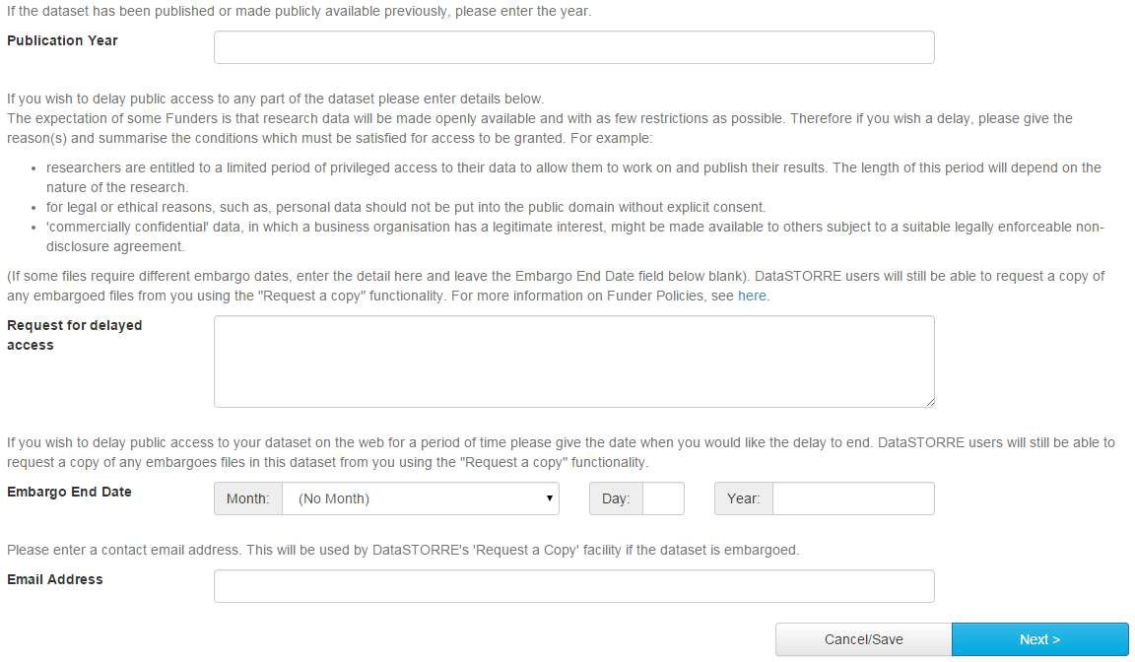
Please read the details of the “Request for delayed access” field carefully. The repository librarian will check the funder requirements to ensure that the embargo is possible.
Once the mandatory fields, at least, have been completed please move to the next page of the submission form by using the Next> button at the bottom of the page.
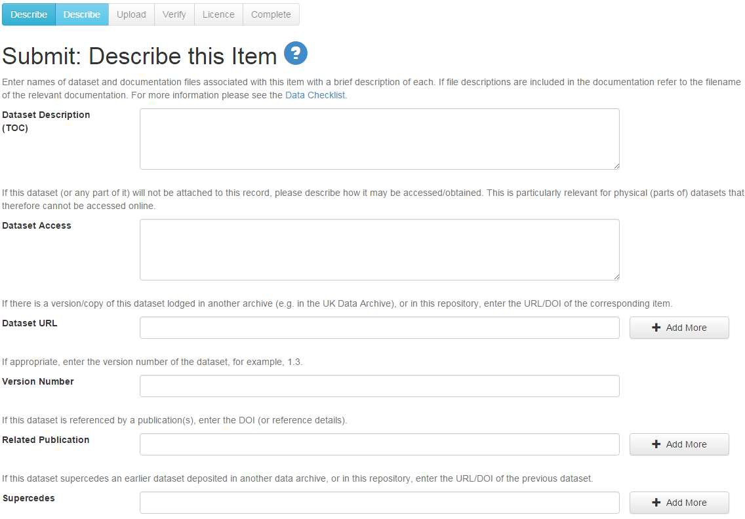

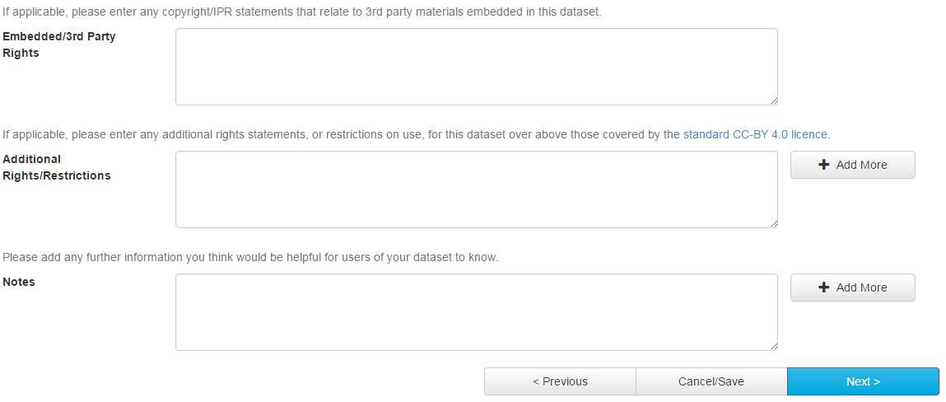

Submitting a file to DataSTORRE

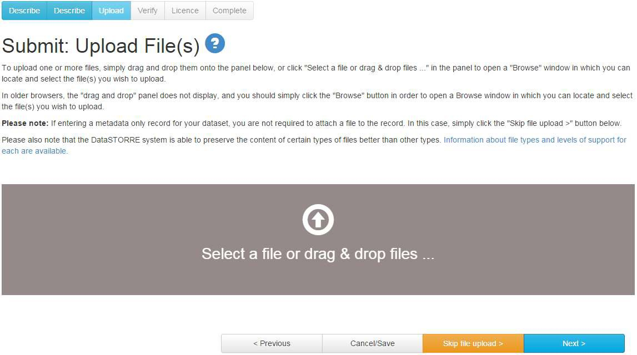

Either drag and drop the files into the grey panel or click on the words in the grey box to open the browse window. If the grey panel does not appear in your browser click the browse button to select the files you wish to upload.
Please note that the Upload File(s) field is not mandatory. If you are entering a metadata only record you can skip this field by clicking the “skip file upload>” field.

Verifying the submission

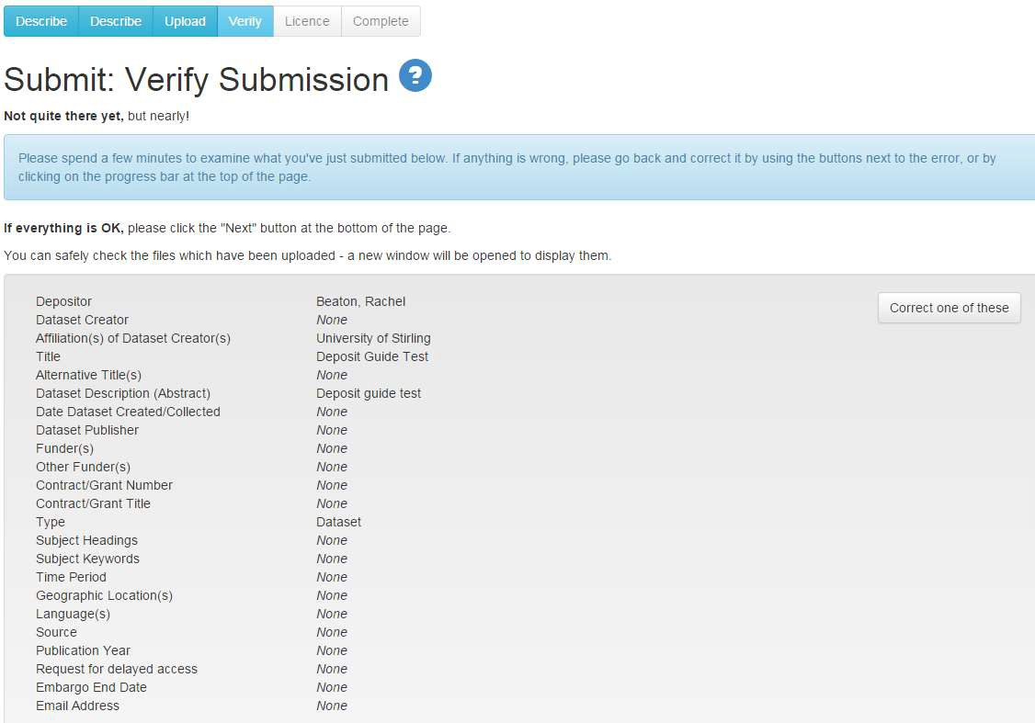

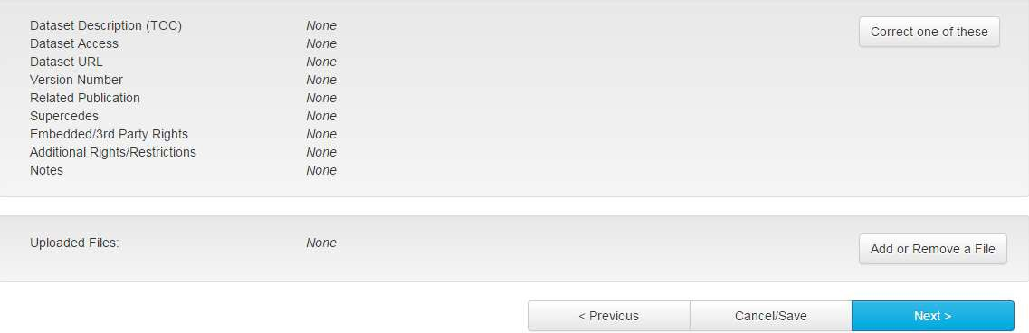

Please check that the information that has been entered about the dataset is correct. Make any amendments necessary.

DataSTORRE Distribution Licence

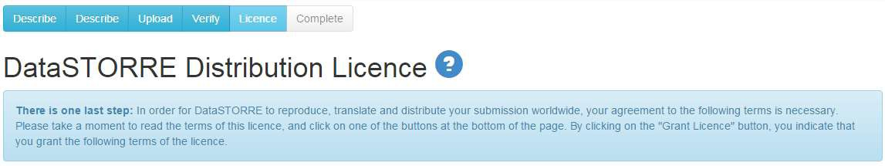

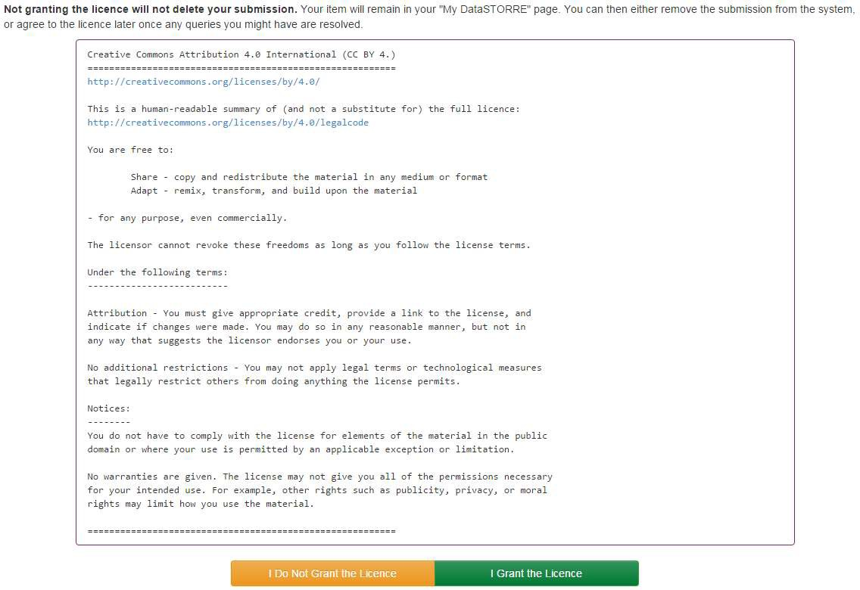

Please read the terms of the licence carefully. Should you not wish to grant the licence or have any unresolved queries please click “I Do Not Grant the Licence”. Certain funders require that the data created as a result of their funding is made publicly available through a certain licence. Once your submission has been deposited the repository librarian will check that this licence has been granted and will contact you with queries.

Your list of submissions

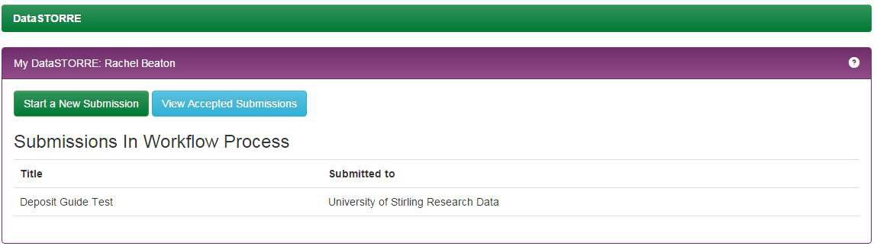

On your home screen on DataSTORRE you will see a list of your submissions and their status within the system.

Help

If you require help with DataSTORRE please contact: repository.librarian@stir.ac.uk

